# Introduction

With adaptive gaming joysticks that are compatible with both PC and XAC being difficult to source globally, MMC aims to provide a very cost-effective, open source customizable joystick, or lineup of joysticks using easy to source components.  Unlike commercial versions, these devices will be designed for Maker assembly with all the digital files necessary to customize key components easily.

The Birch Mini Joystick is a sliding joystick part of the open source Joystick Line Project. This joystick’s main function is to provide a joystick for those with limited range of motion and low dexterity. Sliding joysticks do not require a user to move the joystick at an angle or large distances. Similarly, to the joysticks that were featured in the PlayStation PSP. Making sure this device has a low force so that users are able to easily move the joystick the small distance easily.

This project was also designed with user (Crystal) in mind. Crystal has control of her index finger on her left hand only. Her index finger has a limited range of motion. During a consultation around an adaptive gaming set up she asked if there was anything that was like the ThinkPad TrackPoint joysticks where she would just have to slightly move the joystick in all the directions for it to work without needing to move it at an angle like a traditional thumbstick.

## Who

Who will be using the device?

* Users who are unable to use standard mouse or thumbstick inputs on standard controllers.
* Users may use this as an alternative to mice or standard joysticks for its ability to be mounted at various locations or due to its smaller range of motion
* Only one user will be using this at one time
* This will likely be used with an XAC or another switch interface for gaming purposes but can also be used for digital control.

## What

What must the device do?

* The device must be able to be used for gaming purposes or digital access.
* This device should not be used for mobility control.
* This devices will be able to be used as a joystick input in video games.

## Why

Why will the device be used?

* For users that are unable or prefer to use this joystick over mouse or standard controller thumb stick inputs
* This device will be used when a user is using an access point with limited range of motion

## Where

Where will the device be used?

* Device will likely be used in the home with a PC, console, mobile, or streaming set up.
* This device may be mounted near the user on a table, wheelchair, chair, etc.
* This device may be on a moveable tray or placed on a table.
* This device will not be used with an individuals mouths as not food safe.

## When

When will the device be used?

* This device will be used when the user wants to use it for digital access or during gaming periods.
* These gaming sessions can last up to 5+ hours
* This device will also be used during MMC gaming demos at conferences or in centers.
* This device is NOT to be used for controlling a mobility device.

# Research

## Commercial Options

1. [Inclusive Inc Slider Joystick](https://inclusiveinc.org/en-ca/products/slider-joystick)

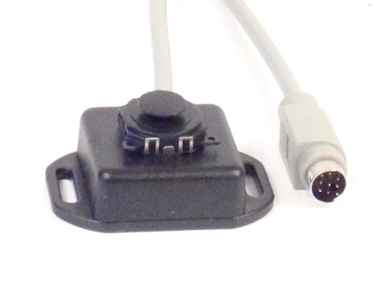

Cost (without shipping): $208.00 CAD

Dimensions: Not given

Features:

* Made to work with [Versatilty v3](https://inclusiveinc.org/products/v3) with circular 8 pin analog joystick port
* Low profile (no dimensions indicated)
* Mounting slots on the side

1. [MINISTIX-SL Warfighters Engaged](https://warfighterengaged.org/shop/ministix-s)

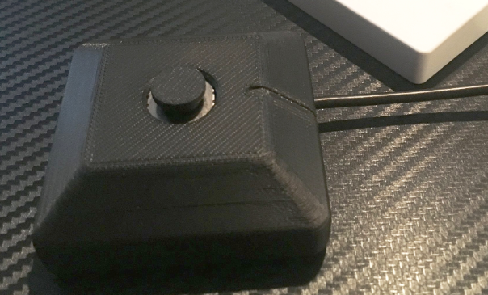

Cost (without shipping): $45.00 USD

Dimensions: Not given

Features:

* ¼-20 threaded hole on the back for mounting.
* 3.5 mm integrated cable

1. [Shein Suction Joystick](https://ca.shein.com/1pc-Phone-Game-Joystick-Suction-Cup-p-10965089-cat-3682.html?url_from=caadplase2207016261720613one-size_GPM&cid=16924668221&setid=&adid=&pf=GOOGLE&gclid=Cj0KCQjw1vSZBhDuARIsAKZlijRy-XMncYK03UyshwmyC0fl6Mfm16aL9F5PqeoGpWY75cMZ6CQgAlsaArkUEALw_wcB)

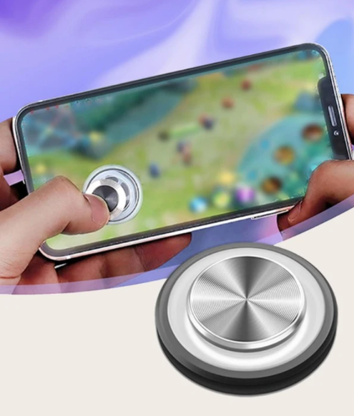

Cost (without shipping): $3.00 CAD

Dimensions: 0.1 x 0.48 x 2.6 cm [HxWxL]

Features:

* Uses suction cup to attach to phone screen to be used in mobile games.
* Low cost and low profile
* No internal electronics, only for use with touch screen

1. [Amazon - PSP type device](https://www.amazon.ca/ZADAI-4-3-inch-Handheld-Console-Portable/dp/B095WXBYSQ/ref=asc_df_B095WXBYSQ/?tag=googleshopc0c-20&linkCode=df0&hvadid=582450275413&hvpos=&hvnetw=g&hvrand=6266306773064355374&hvpone=&hvptwo=&hvqmt=&hvdev=c&hvdvcmdl=&hvlocint=&hvlocphy=9001332&hvtargid=pla-1675176659914&psc=1)

*This example is more of how the device has sliding joysticks incorporated as the PlayStation PSP or Vita are no longer available.

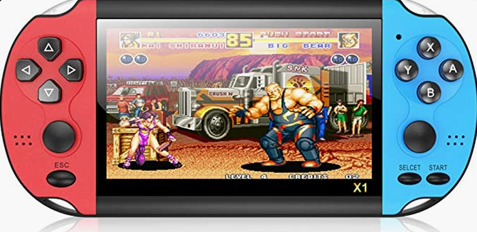

Cost (without shipping): $99.99 CAD

Dimensions: N/A

Features:

* Uses two sliding joysticks in a handheld set up for two handed gaming.
* Replaces the PlayStation PSP and Vita which popularized sliding joysticks in gaming

## Open Source Options:

1. [Slider Joystick MKIII - Ron Nelson](https://www.etsy.com/ca/listing/1191918398/slider-joystick-mkiii-for-xbox-adaptive?click_key=d3bd432ce56c0e6d531869f85e23a9ed4fe7fe8d%3A1191918398&click_sum=caf10b44&ref=shop_home_active_5&crt=1)
   1. Github: <https://github.com/nelsonii/JoystickEnclosures/tree/main/Slider>

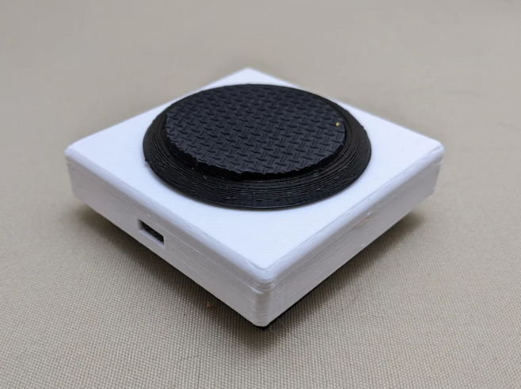

Cost (without shipping):

* Sold for: $77.86 CAD

Dimensions: N/A

Features:

* USB connection (intended for XAC)
* LED indicator light
* PC compatibility and also used with [JoyToKEy](https://joytokey.net/en/)
* Features 3D printed disk topper with rubber 1.5 inch inserts for increased surface area

# Requirements

## Goals

|  |  |
| --- | --- |
| G01 | Keep the device as low profile as possible |
| G02 | Cost effective (i.e. under $80) |
| G03 | Components should be available in minimum quantities needed for the build. |
| G04 | Explore Modular Button Design Concepts, integrated into 3D print and otherwise. If viable within timeline, include feature(s) in the final design. |
| NF05 | The use of support material in 3D printed components should be minimized. |
| NF06 | The number of different filament types used should be minimized. |

## Functional Requirements

|  |  |
| --- | --- |
|  | The joystick design must consist of a variant with USB output and a variant with XAC-compatible analog output. |
|  | The joystick should be able to be used at a minimum distance of 1.5 m away from the device. |
|  | The joystick shall be compatible with the Xbox Adaptive Controller. |
|  | The joystick shall be PC compatible. |
|  | Joystick design must denote use orientation. |
|  | Design will have a topper system to allow easily interchangeable toppers |
|  | The toppers shall not interfere with the regular physical motion of the joystick. |
|  | Topper must have a secure connection that does not spin. |
|  | The joystick shall be designed to be used by either hand. |
|  | Joystick must remain stable while in use. |
|  | Joystick design must reduce possibilities of damage to electronic components of device by reducing openings to internal components. |
|  | Topper designs shall consist of a minimum of a two different toppers.   * Topper styles are dependent on use case research |
|  | Joystick designs must support camera mounting styles |
|  | Joystick designs must support hook and loop fastener styles |
|  | Joystick designs must support the joystick being mounted on the table with no fasteners. |

## Non-functional Requirements

|  |  |
| --- | --- |
| NF01 | Documentation should be maintainable using commonly available software. |
| NF02 | Documentation must be available in a digital format. |
| NF03 | Documentation must be printable. |
| NF04 | Parts must be easily sourced |

## Constraints

|  |  |
| --- | --- |
| C01 | Joystick must be maker manufacturable. (i.e. made with common tools and materials) |
| C02 | Design must be considered low profile and therefore not exceed a total height of 44 mm. |
| C03 | All toppers must not change the strictly translational motion of the joystick |
| C04 | Device must not be used for mobility or medical device control |
| C05 | 3D printed components shall be printable within a 180x180x180mm print volume. |
| C06 | The joystick shall be based on the commercially available Adafruit Mini 2-axis Analog Thumbstick. |
| C07 | Adafruit Mini 2-axis Analog Thumbstick has an envelope of 12.0 mm high x 17.4 mm wide x 17.5 mm deep |
| C08 | Microcontroller must have at least 2 analog pins and 4 digital pins |
| C09 | The joystick must have enough RAM to hold the LipSync Gaming firmware (133 KB) |

## MVP Product Decisions

The Minimum Viable Product for the first iteration of prototyping has been limited to the following requirements and constraints:

1. Compatible with both PC and XAC through USB connection.
2. Basic analog joystick functionality
3. No buttons or additional switch access
4. No user feedback (LEDs, sounds, haptics, etc.)
5. No adjustable user settings – only editable in code for testing purposes
6. Basic tabletop mounting

Later iterations will involve exploring buttons/switch access, adjustable settings, as well as other mounting options. Button/switch access will include exploring Velcro/glued on low profile switches (raindrop, light touch) as well as integrated switches.

# Minimum Viable Product Design

# Ideation

Below are multiple ideas with “napkin” sketches that are potential ideas for the Birch Mini Joystick. These may not be incorporated in the final design but used as a design exercise.

## Enclosure Ideation

The enclosure will enclose the joystick and electronic components. This ideation is for a PCB or protoboard with 4 corner mounting holes. The enclosure will also need to protect the inner components from regular use. A limited amount of printable pieces is ideal to speed up print times and reduce rates of failure. A simple two-piece enclosure (top and bottom) with fasteners is secure and easy to assemble while allowing maker or user/secondary user to be able to easily open device for troubleshooting.

For this initial design a square with rounded corners was chosen as it allows for a better surface area on the top of the housing for switches. Such as mounting a light touch switch on the top or side of the enclosure to test out if user would benefit from built in or mountable switches.

### Idea 1: Simple Enclosure

Using two pieces (top and bottom) and using a set of 4 screws to connect the pieces together. A hole in the top piece for access to the Adafruit Mini 2-Axis Joystick and mounting holes for the screws on both top and bottom components. The MMC analog joystick design uses this approach in its current (as of writing this) v1 stage. A basic sketch of the idea is below:

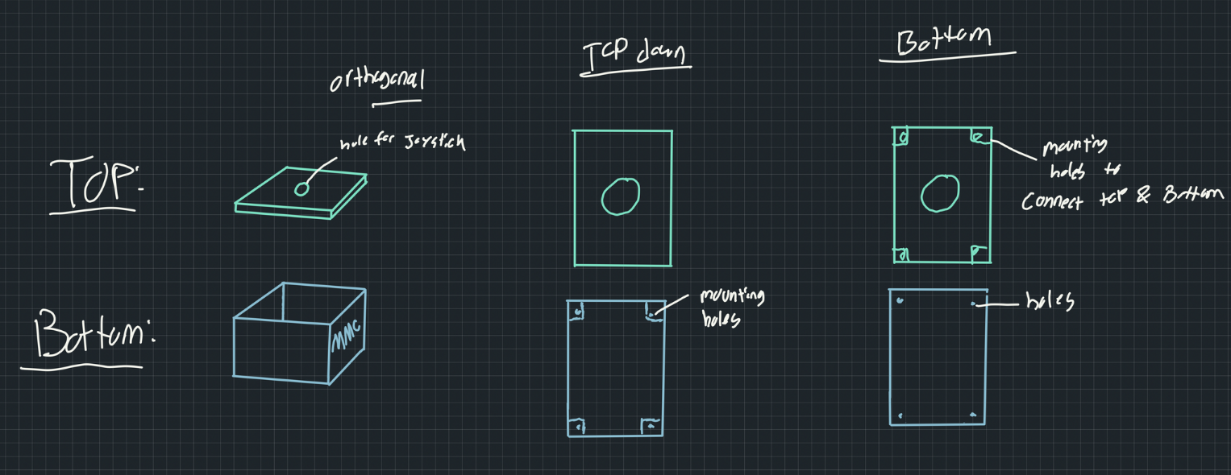

### Idea 2: Overflow

This concept came from hosting build events for MMC devices such as the Analog Thumbstick and Interact Switch where it is common for makers to struggle to line up mounting holes when holding two components together. Initially thinking of guiding rails or “plug and socket” type of fits to align the holes. These can have tolerancing issues and thinking of “gaming aesthetics” often two tone colors are used (ex. DualShock 4 controllers). Therefore, in this design using the top component to overhang over the bottom component would more easily align the mounting holes while creating a neat aesthetic. Initial thoughts of downsides could be slightly increased print time although likely minimal.

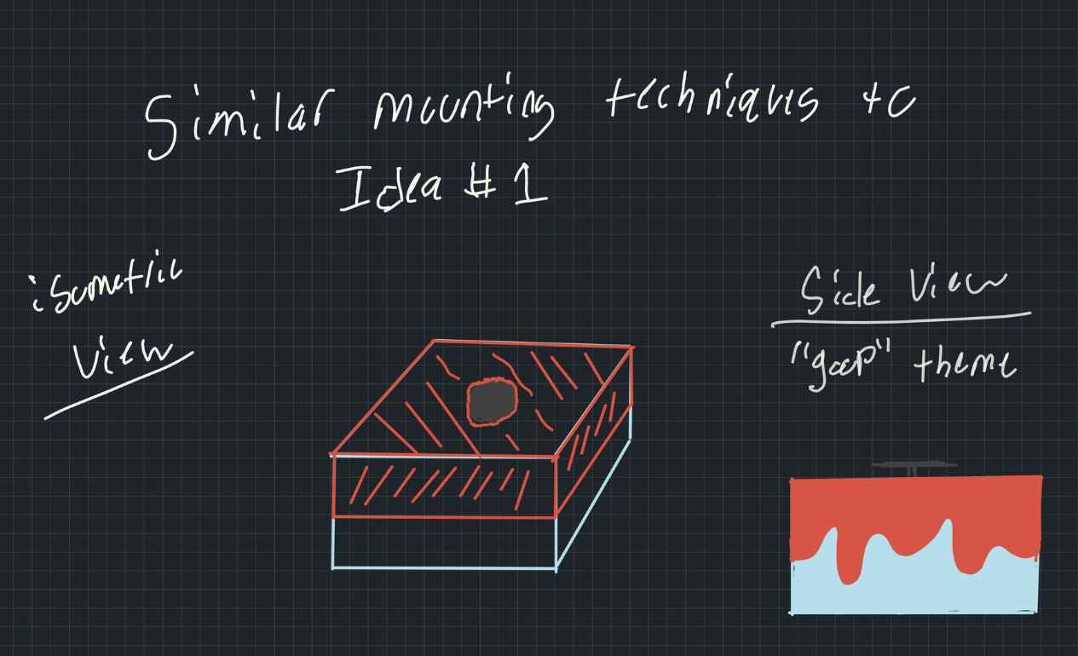

## Modular Mounting Options

* Slide on component

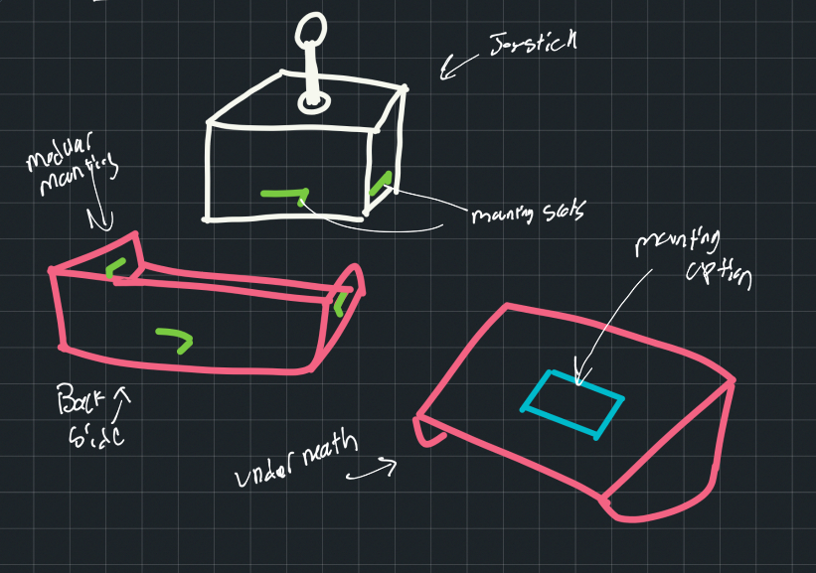

## Wearable Option

This option would be an alternative to the more standard mounting methods of AT such as fixed mounting using bolts, hook and loop fastener (e.g., VELCRO), or clamps. Instead this design would be attached the user directly. This option would allow for unique points of access for users where instead of using the motion of a limb (ex. finger) to move the joystick, the motion of the limb itself and a contact surface/natural grips can be utilized. An example of this could be the MMC [Custom Single Switch Kit](https://makersmakingchange.com/project/custom-single-switch-kit/) which uses heat mouldable plastic to mold to users limbs for usage. An example of how this sliding joystick may be placed is shown below using a flexible woven smart watch band with a smartwatch. The first photo shows laying the hand flat and using the table to move the joystick. The second being using a grip to use a combination of fingers to move the joystick.

|  |  |  |
| --- | --- | --- |
|  |  |  |

The joystick could be designed with attachment points at each side of the device which could be attached to a users limb. This poses a problem of making sure the joystick is small enough to be able to have a wireless communication to the device (wired is undesirable for wearables). A wireless link box could be also worn or near the user that could communicate the device.

|  |
| --- |
| Wearable strap/joystick à Cables to wireless link à Bluetooth on PC or receiver link attached to XAC. |

Another alternative to this could be a ring type of set up that could be fully 3D printed. Ring sizes can be tested at home through different low cost sizing mechanisms and parametric design could be used for right sizing. This design would also require a wireless link type of device to ensure the ring is as light as possible.

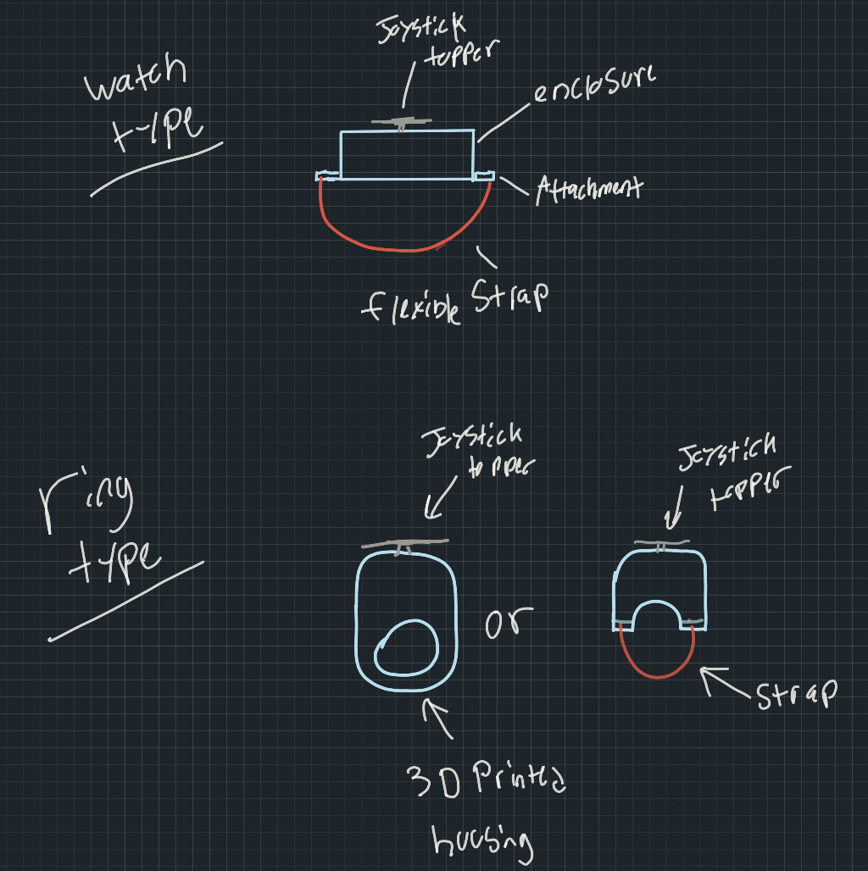

## Handheld Version

Given most PSP style joysticks traditionally have been held in the hand while playing, thinking of a user either mounting it on their palm through a strap or grasping the device and using a thumb to interact with the joystick. This is similar to how the Nintendo Wii Nunchuk remotes joysticks work (also imitated by Xbox with peripheral for XAC):

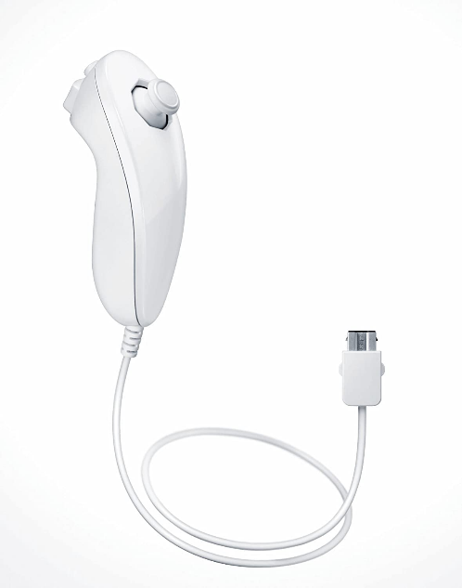

Image Source: <https://www.amazon.ca/Nintendo-of-Canada-2110166-Controller/dp/B000IMYKQ0>

## Toppers

### Interchangeable toppers – Common fitting

* Component that would be modeled to fit all various types of off the shelf joysticks that would have connector ridges or potentially threads that fit a line of toppers.
* Between line of MMC joysticks all the toppers will be able to fit any joystick as the topper fitting only needs to be modled once for each commercial joystick option.

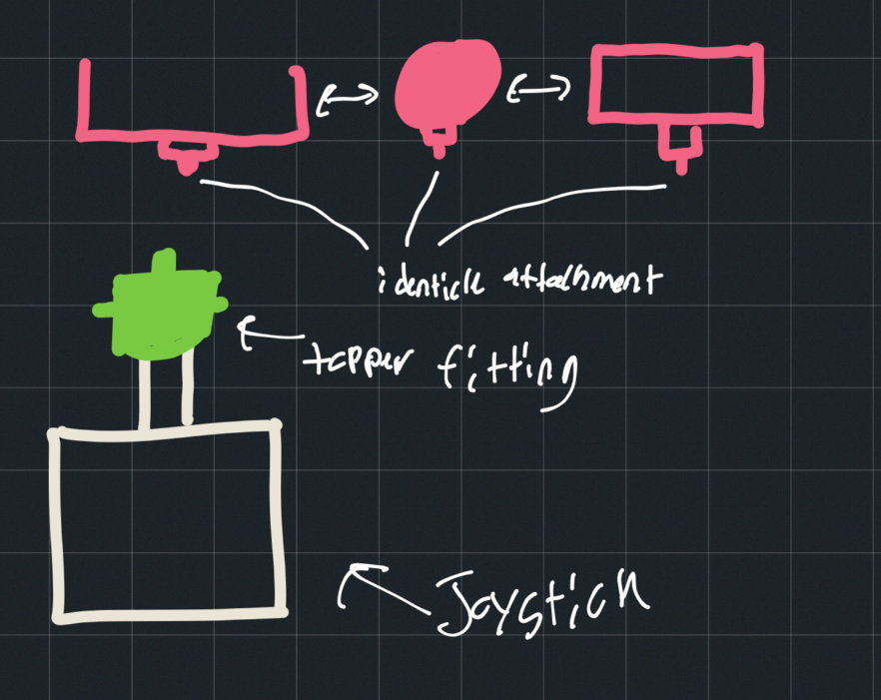

### Topper attachment to Adafruit Mini 2-Axis Joystick

This ideation is around the different types of attachments that could be made to the Adafruit Mini 2-Axis Joystick. This joystick poses some difficulties with the build in topper having some play with the current tolerance fit with the peg. The built in topper and joystick look like the following:

|  |  |  |  |
| --- | --- | --- | --- |
|  | |  |  |
|  | | |

With these small components mounting large external toppers may be difficult given the force that can be exerted when gaming. A few separate ideas for mounting are sketched below:

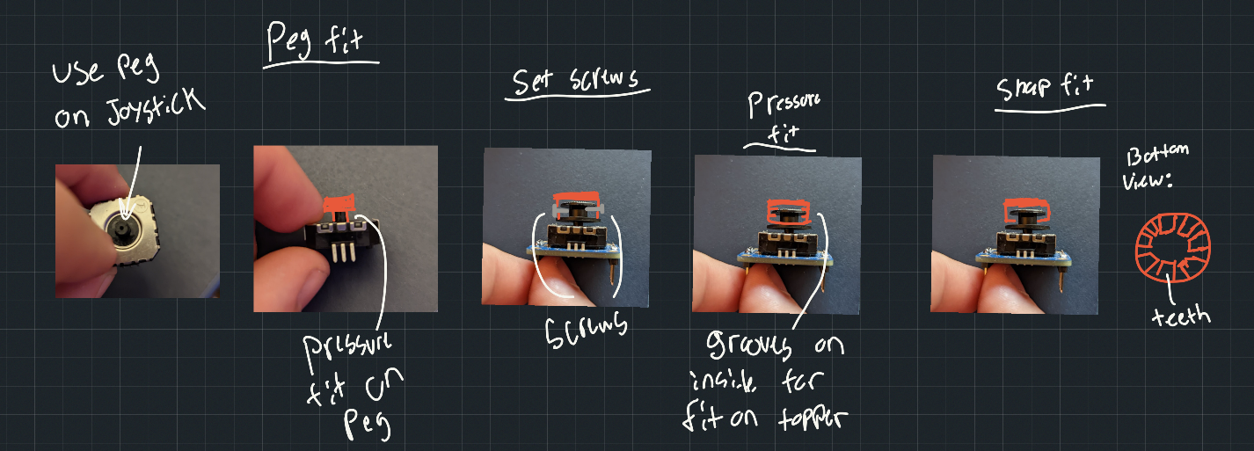

**Peg Fit** – Attaching 3D print directly to the peg alike the standard topper itself.

**Set Screws** – Using small set screws to attach to the peg or standard topper of the joystick to create friction for the joystick to stay on

**Pressure Fit** – Creating a highly tolerance print such that can be pressed onto the top of the joystick standard toppers that will allow the sections of the topper disks to fit within cut-outs to keep the topper stable.

**Snap Fit** – Using a range of teeth that are thin enough to flex over the standard topper and snap over the highest disk on the standard topper.

It was decided to use a peg fit to attach the toppers. The toppers would have a hole that would press onto the peg, the profile of this hole would match the profile of the peg.

# Conceptual Design

## Electrical Conceptual Design

### Concept 1 – Protoboard

This concept uses a protoboard design with the Adafruit joystick, XAIO RP2040 microcontroller, and LED encased in a controller. Wires will be used to make the circuit connection between the joystick and the microcontroller for analog and digital inputs. The protoboard will increase the size as it is not custom fit to the microcontroller and joystick and there will be some space between the components.

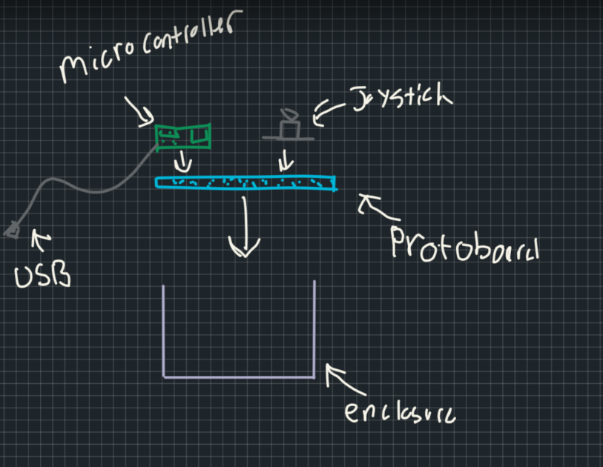

### Concept 2 – Custom PCB

This method would require a custom PCB to be made to fit the microcontroller and joystick in the tightest possible configuration. This design would require the PCB board to be fixed to the enclosure and the joystick and microcontroller to be soldered to the PCB.

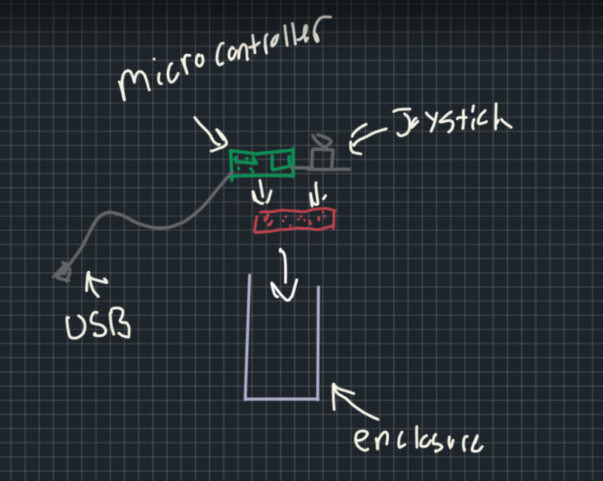

### Concept 3 – Direct to Microcontroller

This method would use Dupont cables to directly connect the microcontroller to the joystick and then the 3D housing would secure both components.

### Electrical Concept Decision

For the MVP version of the design, Concept 1 with protoboard, microcontroller, and Mini Adafruit 2-axis joystick was chosen. This decision was made on eliminating need for extra design of microcontroller and a more secure connection/less complex printing of a direct connection. However this design will include some unutilized space as the smallest 4 cm x 6 cm protoboard is a bit bigger than necessary. A rough sketch of the wire connection can be found below:

General set up of the protoboard with the RP2040 and the joystick. The joystick will be placed as close to center of the protoboard as possible given the size of the 4 cm x 6 cm board to allow for the joystick to be centered on 3D print enclosure.

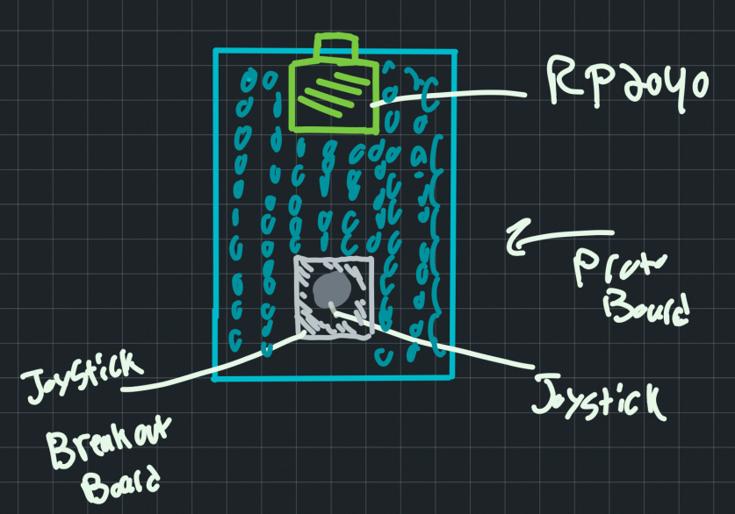

## Firmware Conceptual Design

The firmware must translate the measured position of the two axes of the joystick and convert them into USB HID signals.

### Initial MVP Code

For the initial testing for this joystick device, the code must provide the following:

* USB HID output for PC and Xbox XAC compatibility
* Ability to save deadzone and edit variable within code on a scale of (1-10) with 10 being most “wide” dead zone and 1 being most “narrow”

### Future Ideation Features

* Calibration of joystick
* Initialization of center point
* Joystick response profiles (similar to on the XAC)
* Changeable features of joystick easily by user (potential web based platform)
  + Response profiles
  + Deadzone

# Detailed Design

The design consists of electronic hardware mounted into a two-piece 3d printed enclosure. This section outlines detailed information and design decisions for the different portions of the design.

## Electrical

The electrical design consists of the joystick, a microcontroller, and a USB cable to connect to the host device.

### Microcontroller Selection

The following Table includes the list of considered microcontrollers. This initial list was chosen by compiling the top 3 microcontroller manufacturers (SeeedStudio, Adafruit, and Raspberry pi) newer boards with USB HID option. The following list was compiled:

Table 1: Microcontroller Comparison for Birch Mini Joystick Design

| **Dev Board** | SeeedStudio XIAO SAMD21 | Adafruit  QT py M0 | Adafruit QT  Py RP2040 | Adafruit QT  Py ESP32-S3 | SeeedStudio XIAO  nRF52840 | SeeedStudio XIAO  nRF52841 Sense | SeeedStudio XIAO  RP2040 | Raspberry pi pico |
| --- | --- | --- | --- | --- | --- | --- | --- | --- |
| **MCU** | ARM  Cortex-M0 | ARM  Cortex-M1 | RP2040 32-bit  Cortex M0+ | ESP32-S3 | Nordic nRF52840):  ARM Cortex-M4 | Nordic nRF52840):  ARM Cortex-M4 | RP2040 32-bit  Cortex M0+ | RP2040  (Dual Cortex-M0) |
| **Cost (CAD$)** | $7.5-$7.75 | $10.69 | $14.18 |  | $15.75 | $24.26 | $7.69 | $5.6-$6.9 |
| **Availability** | 4,617 available from digikey | 395 available from digikey | 73 available from digikey | Not in Digikey.ca yet | 350 available from  digikey | 381 available from  digikey | 5999 available from  digikey | 44,829 available from digikey |
| **Clock Speed**  **(MHz)** | 48 | 48 | ~125 | 240 | 64 | 64 | ~125 | ~125 |
| **FLASH memory** | 256KB | 256KB | 256KB | 8MB | 1MB and  2 MB QSPI flash | 1MB and  2 MB QSPI flash | 256KB | 2MB QSPI |
| **SRAM** | 32KB | 32KB | 8 MB | 512KB, no PSRAM | 256KB | 256KB | 8 MB | 264kB |
| **EEPROM memory** | None | None | None | None | None | None | None | None |
| **Total pins** | 14 | 14 | 14 | 14 | 14 | 14 | 14 | 43 |
| **Digital pins** | 11 | 11 | 11 | 11 | 11 | 11 | 11 | 26 |
| **I2C Interface** | 1 I2C | 1 I2C | 2 I2C | 2 I2C | 1 I2C | 1 I2C | 2 I2C | 1 I2C |
| **SPI Interface** | 1 SPI | 1 SPI | 2 SPI | 1 SPI | 1 SPI | 1 SPI | 2 SPI | 1 SPI |
| **Input Voltage (Limit)** | 6V | 6V | 6V | 6V | 6V | 6V | 6V | 5.5V |
| **Operating Voltage** | 3.3V | 3.3V | 3.3V | 3.3V | 3.3V | 3.3V | 3.3V | 3.3V |
| **Voltage Regulator** | XC6206P332MR | AP2112K-3.3 | AP2112K-3.3 | AP2112K-3.3 | XC6206P332MR | XC6206P332MR | XC6206P332MR | RT6150B-33GQW |
| **Dimensions** | 20mm × 17.5mm × 3.5mm | 20mm × 17.5mm × 3.5mm | 21.8mm × 17.5mm × 5.8mm | 21.7mm × 17.8mm × 5.7mm | 21mm × 17.8mm x ??mm | 21mm × 17.8mm x ??mm | 21mm × 17.8mm x ??mm | 51mm × 21mm |
| **Bootloader** | Arduino IDE or CircuitPython | Arduino IDE or CircuitPython | Arduino IDE or CircuitPython | Arduino IDE or CircuitPython | Arduino IDE or CircuitPython | Arduino IDE or CircuitPython | Arduino IDE or CircuitPython | Arduino , CircuitPython |
| **Direct replacement option** | 7 options | 7 options | 7 options | 7 options | 7 options | 7 options | 7 options | Manufacturered by RaspberryPi,SeeedStudio,Sparkfun. Alternative: Pimoroni Pico LiPo |
| **Bonus** |  |  |  |  |  |  |  |  |
| **SD Card slot** | None | None | None | None | None | None | None | None |
| **Built-in screen** | None | None | None | None | None | None | None | None |
| **RGB LED** | None | Yes | Yes | Yes | Yes | Yes | Yes | None |
| **USB Type** | USB-C | USB-C | USB-C | USB-C | USB-C | USB-C | USB-C | Micro-USB B |
| **USB HID** | Yes | Yes | Yes | Yes | Yes | Yes | Yes | Yes |
| **Battery Charger** | None | None | None | None | None | None | None | None |
| **Wi-fi** | None | None | None | Yes | None | None | None | None |
| **Bluetooth Built-in support** | None | None | None | Yes | Yes | Yes | None | None |
| **Qwiic/Stemma/Grove Connector** | None | Yes | Yes | Yes | None | None | None | None |
|  |  |  |  |  |  |  |  |  |
| **Links** |  |  |  |  |  |  |  |  |
| Developer | [Link](https://www.seeedstudio.com/Seeeduino-XIAO-Arduino-Microcontroller-SAMD21-Cortex-M0+-p-4426.html) | [link](https://www.adafruit.com/product/4600) | [Link](https://www.adafruit.com/product/4900) | [Link](https://www.adafruit.com/product/5426) | [Link](https://www.seeedstudio.com/Seeed-XIAO-BLE-nRF52840-p-5201.html) | [Link](https://www.seeedstudio.com/Seeed-XIAO-BLE-Sense-nRF52840-p-5253.html) | [Link](https://www.seeedstudio.com/XIAO-RP2040-v1-0-p-5026.html) | <https://www.raspberrypi.com/products/raspberry-pi-pico/> |
| Digikey | [Link](https://www.digikey.ca/en/products/detail/seeed-technology-co-ltd/102010328/11506471) | [Link](https://www.digikey.ca/en/products/detail/adafruit-industries-llc/4600/13543375) | [Link](https://www.digikey.ca/en/products/detail/adafruit-industries-llc/4900/16680568) |  | [Link](https://www.digikey.ca/en/products/detail/seeed-technology-co-ltd/102010448/16652893) | [Link](https://www.digikey.ca/en/products/detail/seeed-technology-co-ltd/102010469/16652896) | [Link](https://www.digikey.ca/en/products/detail/seeed-technology-co-ltd/102010428/14672129) | <https://www.digikey.ca/en/products/detail/raspberry-pi/SC0915/13624793> |
| Mouser | [Link](https://www.mouser.ca/ProductDetail/Seeed-Studio/102010328?qs=GBLSl2AkirtQWO8CTzEK9g%3D%3D) | [Link](https://www.mouser.ca/ProductDetail/Adafruit/4600?qs=hd1VzrDQEGi752M4exorSA%3D%3D) | [Link](https://www.mouser.ca/ProductDetail/Adafruit/4900?qs=pBJMDPsKWf2NgbJSZrvxVw%3D%3D) |  |  |  |  |  |

#### Microcontroller Criteria

For the Birch Mini Joystick to meet the requirements detailed in its own requirements along with the joystick projects requirements the following specifications must be met by the microcontroller:

Table 2: Criteria for Birch Mini Joystick Microcontroller Selection

|  |  |  |
| --- | --- | --- |
| **Criteria** | **Requirement** | **Description** |
| **Size** | F25, F26 | The size of the device must be as small as possible and fall within the given ranges described in the requirements. Therefore, the smaller the microcontroller the better. |
| **USB HID** | F7, F9 | The microcontroller must have the ability to provide USB HID |
| **User Feedback** | F24 | The joystick must be able to provide the user feedback (i.e. status light potentially) |
| **Analog Pins** | F2, C015 | The microcontroller must have a minimum of 2 analog pins to be able to connect the joystick |
| **Digital Pins** | C015 | The microcontroller does not necessarily have to have a certain amount digital pins but the option of having more digital pins (balanced with size) is beneficial for possibility of future add-ons or switch inputs. |
| **Availability** | F10 | Ensuring the microcontroller has plenty of current stock and will be available in the future. Also easily bought by a maker in a single quantity. |
| **Cost** | G03 | Affordable microcontroller to ensure that the device is as low cost as possible. |
| **SRAM** | C016 | Must be able to fit the memory of the LipSync Gaming firmware (133KB) as a benchmark. More memory is ideal. |

#### Microcontroller Selection

Analyzing the data shown in Table 1 and comparing the microcontrollers based off of the criteria shown in Table 2 it was decided that only the SeedStudio XIAO RP2040 and the Raspberry Pi Pico should be compared. This decision was made as the other options cost was often over 2x the XIAO RP2040 or the Pico with non-considerable benefits. Also, the current availability of both the XIAO RP2040 and Pico are significantly more than the other options.

**The decision was made to proceed design with the XIAO RP2040** rather than the Pico. For the reasons stated in Table 2, the XIAO RP2040 has a considerable smaller size, larger SRAM, and has the option for a built in LED. However, the Pico does have more digital inputs and more current stock but these were seen weighted less than the size of the microcontroller. The large distinction of the Birch Mini Joystick design is its size and linear action of the joystick. With the XIAO RP2040 the size can be considerably smaller than with the Pico.

### Schematic

RP2040 pin information can be seen in photo below. From the breakout board on the joystick the ports will be connected to the 3.3V Power, GND, A0, and A1 ports of the XAIO RP2040.

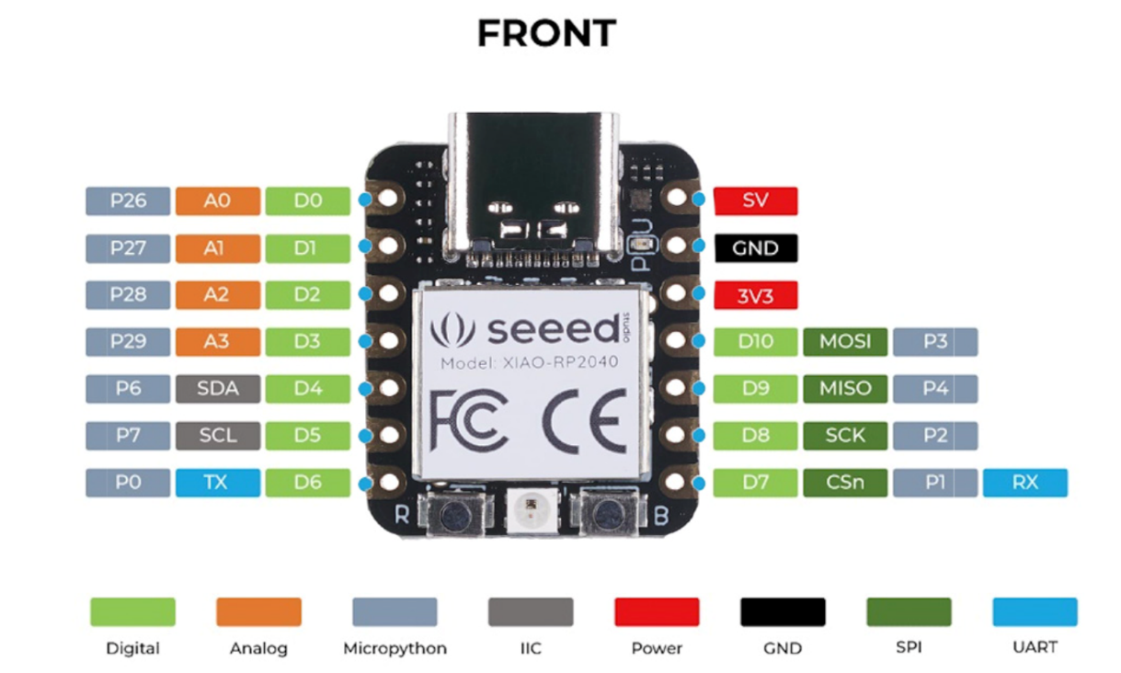

This is a rough sketch of the wires that will need to be placed on the protoboard to make the connection between the joystick and the RP2040.

* + Red – Power (3.3V)
  + Black – GND
  + Blue – A0
  + Yellow – A1

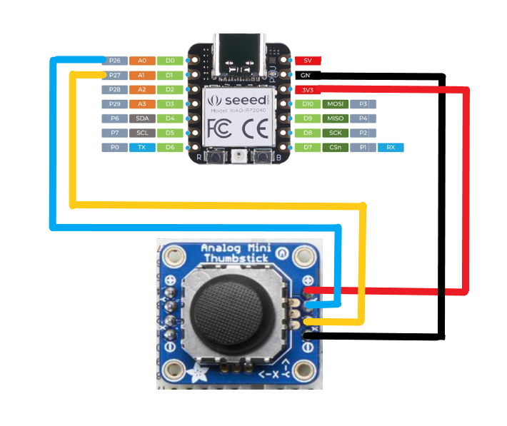

Figure 1 Wiring Sketch

Alignment of photo above is not representative of final placement of joystick and microcontroller on protoboard but rather used for a basic wiring diagram of where to make the connections.

### Wire Selection

24 AWG wire to be consistent with other designs and will work with given voltages.

### Protoboard Component Placement

Placing the microcontroller and Adafruit joystick on the protoboard can be done in many ways. The enclosure housing design will be simpler and reduce unutilized 3D print space if the joystick can be in the center of the design. This also will allow for switches to be mounted on each side of the top of the housing.

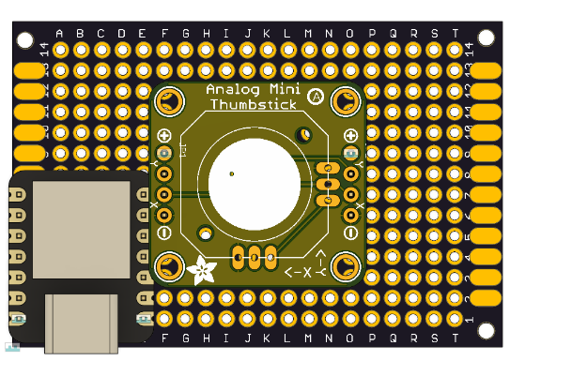

With analog joystick in the middle there is no room for the microcontroller. The joystick must be moved to allow space on the PCB for the microcontroller. This will require the housing to counter this to allow the joystick to be in the middle of the housing.

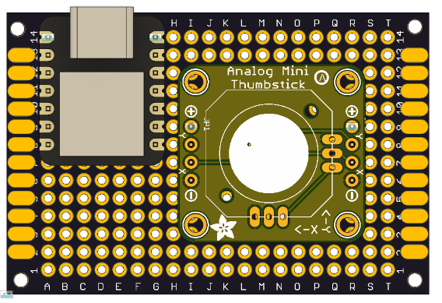

This design puts the joystick in the center of protoboard on the shorter side but out of center on the longer side with it shifted to one side.

Using the orientation in the protoboard, the default “front” of the joystick has to be decided. In the programming any direction can be chosen for the front so the user can technically use it from any angle. For the default case, the side with the microcontroller will be the front, as shown with the text below. This decision was made to ensure that the USB cable is on the other end of the design and the joystick is close to where the user may be resting their hand. The area in front also allows for potential for small switches like the Raindrop or Light Touch to be mounted. The final position is as such:

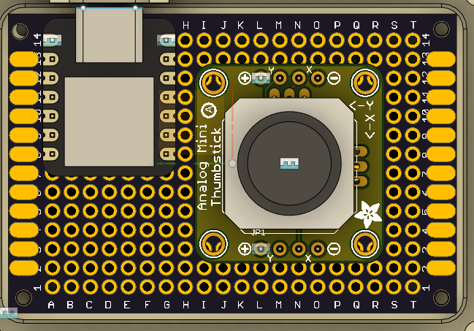

Back or “down” direction

Front or “up” direction

## Mechanical

Resources used:

* <https://www.hubs.com/knowledge-base/enclosure-design-3d-printing-step-step-guide/>
* <http://www.whatimade.today/3d-printing-experiences-finishing-a-project-in-style/>
* <https://www.instructables.com/3D-Printed-Electronic-Enclosure/>

### Component 1 – Bottom of Enclosure

As discussed in the enclosure ideation, this primary version intended on user feedback will be a rectangular design. This is due to consistency in open source and commercial options having a square base, protoboard being rectangular, and a shape that will allow a good baseline from users to give suggestions for future designs.

#### General Shape

The protoboard is 4 cm by 6 cm and is the main determiner of the length and width of the design. There must be space inside of the housing for mounting of the proto-board and top enclosure. Giving 2 cm on both the width and height (total 6 cm x 8 cm) was the initial thought of the enclosure and rounding the corners for aesthetics and to reduce sharp corners. The shell of the design has 2 mm thick walls to fall within the standard 0.4 mm nozzle diameter for strength and quality of printing.

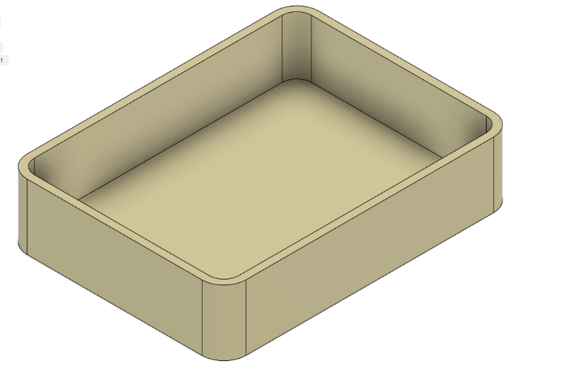

#### Protoboard Mounting options

The protoboard has four 2 mm holes on each corner of the board. There are three ways this proto-board with electronic components attached can be mounted to the bottom piece of the enclosure.

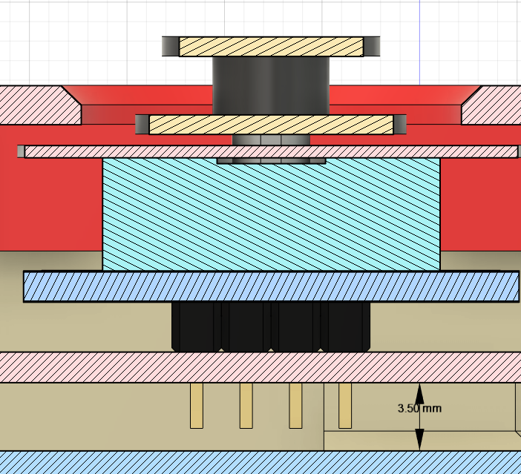

The proto-board must be raised up 3.5 mm to add clearance for the male headers and wires that will be connecting the joystick to microcontroller. These headers are originally longer, but can be trimmed during the assembly process so that less clearance is needed.

##### Fasteners

This method would be using fasteners small enough to fit through the 2 mm mounting holes on the proto-board and get rotated into the 3D print housing. Options for fasteners that would be small enough to fit into the 2 mm holes and are equal to or less than 8 mm (top of proto-board to bottom of enclosure is 8.57 mm) in length are:

|  |  |  |  |  |
| --- | --- | --- | --- | --- |
| Type of Fastener | Cost (CAD) | QTY | Link | Notes |
| M2 Self Centering Screws | $12.99 | 1000 | [Amazon](https://www.amazon.ca/dp/B00GMQDSRI/ref=cm_sw_r_apa_i_E8JPY5XFYVGFR0DWK50V_0) | Come in pack of 1000 |
| M2 Machine Screws | $0.65-5.73 |  | [PCboard Link](https://www.pcboard.ca/metric-stainless-pan-head-screw)  [digikey](https://www.digikey.ca/en/products/detail/apm-hexseal/RM2X8MM-2701/612919) | Machine screws are not self threading. Price is for 5 of them. |
| M2 Standoffs | $18.71 |  | [Amazon](https://www.amazon.ca/HVAZI-Male-Female-Spacer-Standoffs-Assortment/dp/B071KDS14D) | This is a full set of various sizes of M2 standoffs with nuts and screws. |
| M2 Bolt/Nut | $15.11 |  | [Amazon](https://www.amazon.ca/Hilitchi-180-Piece-Stainless-Socket-Assortment/dp/B01N1WDUK0/ref=sr_1_6?keywords=M2%2Bbolt&qid=1666661115&qu=eyJxc2MiOiI0LjYyIiwicXNhIjoiNC4zNiIsInFzcCI6IjMuNjUifQ%3D%3D&sr=8-6&th=1) | This is a full set of various m2 bolts in several lengths. |

Looking into purchasing options for M2 Standoffs, machine screws, and bolts and nuts it can be seen that the M2 machine screws are the most cost effective. Although it was unclear if using machine screws that are not self threading directly into 3D prints would be effective. This was tested out using a fastener testing rig with m4 bolts that were on hand. The right mounting hole in the photo below was used for testing. The other mounting hole was disregarded.

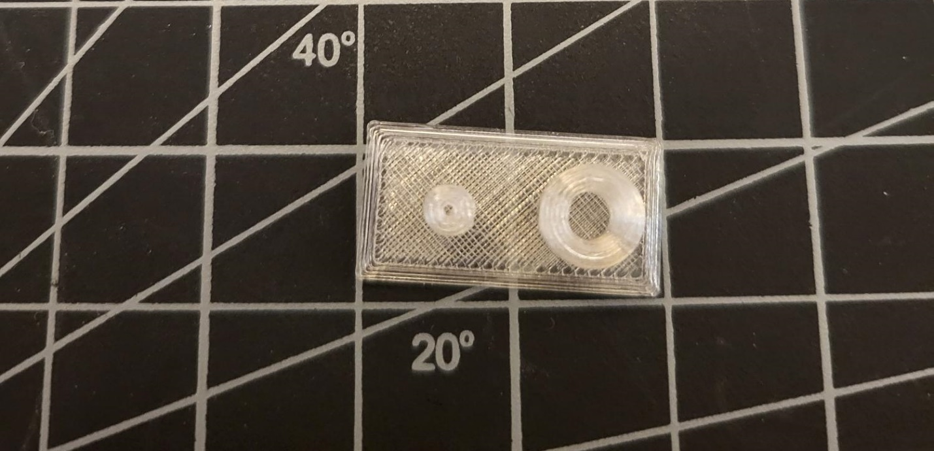

I first made the hole on the simulated 3D printed mounting hole exactly 4 mm. The M4 bolt slid inside with almost no resistance and would not have worked as a solution for connecting the proto-board to the housing. The hole diameter was then reduced to 3.8 mm and at this tolerance the machine screw threaded inside as desired. The fixture is sturdy and is resilient to screwing the bolt in and out as users or makers may need to undo these screws in the future.

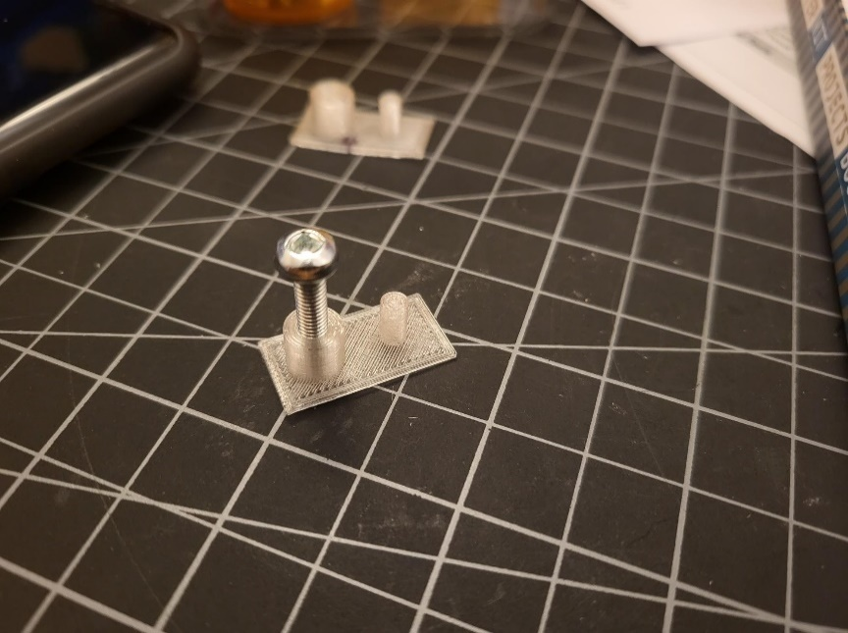

##### Bracket Design

This design would be used to eliminate the use of the 2 mm mounting holes on the proto-board as they are quite small and it is difficult to source M2 type of connectors. This design would use a outline on the bottom piece of the enclosure that the proto-board would sit in and then a separate bracket piece would be placed on top of the electrical assembly and screwed into the outline. This would fix the proto-board in all directions and allow the 3D printed mounting holes for the bracket to be changed to more common fasteners. A basic sketch is below:

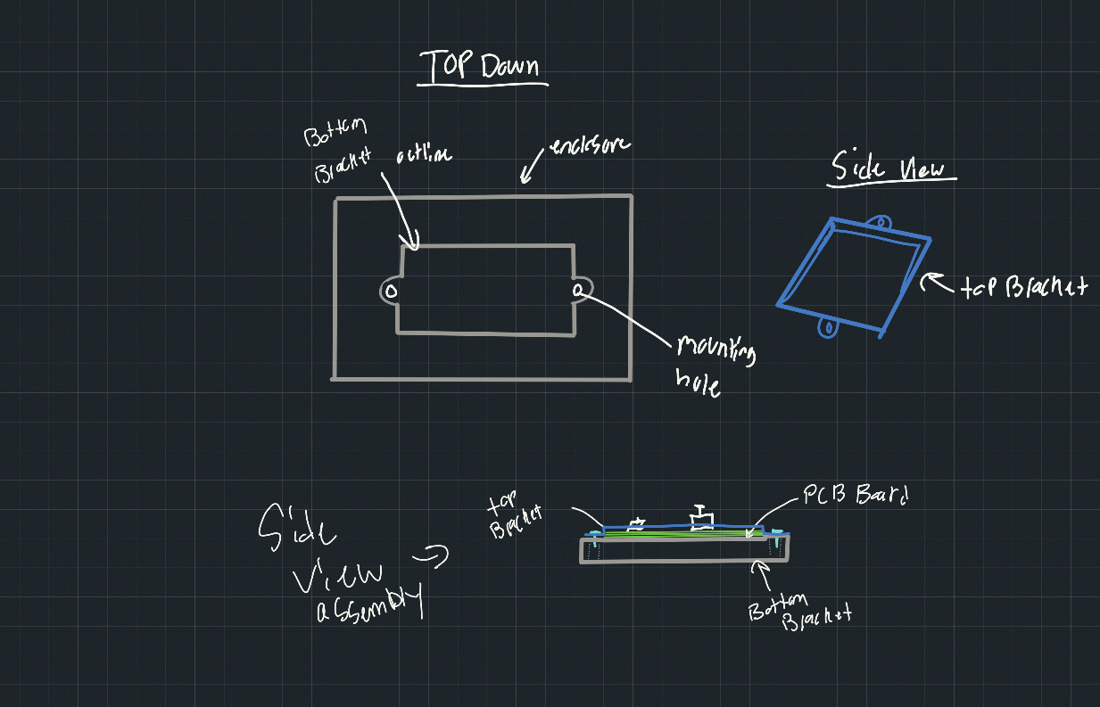

##### Compliant Mechanism

This design does not use fasteners at all but rather utilizes a 3D print snap fit to contain the proto-board. There is many ways to approach this design but user Reneaye on GitHub (<https://github.com/raydiy/PCB-Mount>) has documented their process for designing options for this with a parametric design. These could be used to hold the protoboard in place and eliminate the use of fasteners. The benefit here is to reduce cost of the fasteners and speed up assembly.

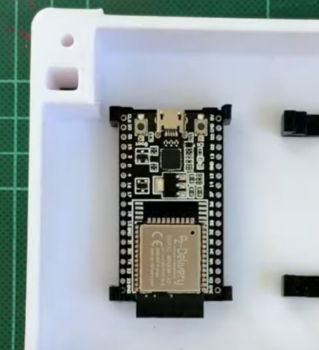

Photo from: <https://www.youtube.com/watch?v=6KTznAQglPs>

A potential downside of this design would be fatigue of the 3D print over time or the plastic becoming brittle over time. A new housing would have to be printed as a replacement if these mounting components failed.

##### Mounting Decision

Considering the above three options of fasteners, bracket design, compliant mechanisms for mounting the protoboard the **fastener** design using M2 x 6 mm self tapping screws was chosen. The M2 x 8 mm machine screws may have worked but without accurate testing the self tapping screw that are common for 3D prints was chosen. The reasons for this choice are:

**Design time** – Given the design time of this enclosure the simplicity of the fastener design will result in a reliable design that can be tested when materials are ordered. The bracket and compliant mechanism will likely require more tweaking when parts are ordered and will delay testing.

**Component Failure** – The bracket and compliant mechanism design introduces more components to the design that are 3D printed and have a higher likelihood of failing.

**Cost** – The fastener design is the highest cost mounting option. Although, with the 5 screws costing (at the more expensive Digi-Key option) being ~ $5.00 this is a relatively negligible amount with the design still falling below the maximum cost range outlined in the requirements.

**Intent of Version of Design** – This version (0.1) of the Birch Mini Joystick is intended to be a fast and simple version to test the usage of this type of joystick in adaptive gaming. Getting user feedback on this design to make improvement is one of the high priorities.

#### Protoboard Mounting Posts

Given the decision in the section above going with M2 machine screws and the testing done with the M4 machine screw the nominal inner diameter of the mounting hole will be 1.8 mm to allow grip for the threads of the screw. The thickness of the solid part of the mounting post is chosen to be 2 mm.

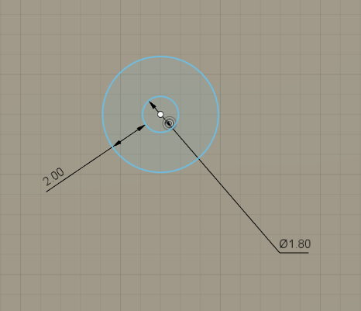

A 1.5 mm fillet is added at the bottom of the posts for rigidity when screw is being inserted into the post and reduce the stresses at the location where the enclosure and mounting posts meet. The 4 mounting posts now look like the following:

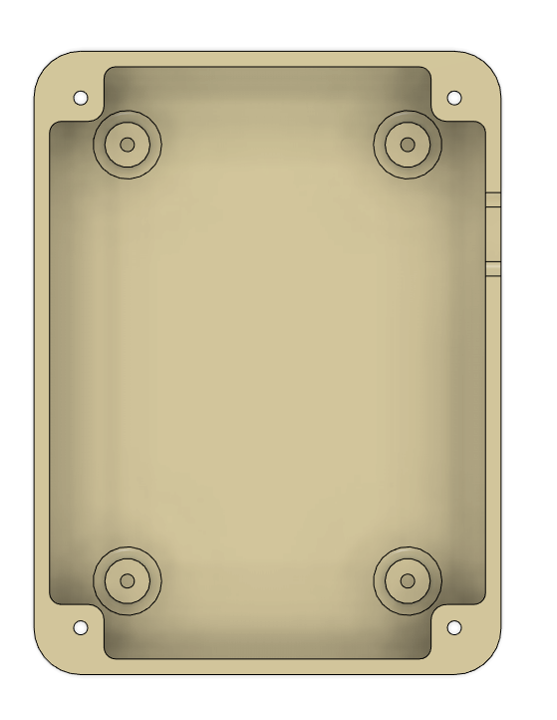

Connecting material was added to the in between the posts for rigidity and to reduce the chance of off centering of the holes when printing.

### Component 2 – Top of Enclosure

#### General Shape

The topper of this design will line up exactly with the top face of the bottom piece of the enclosure. This top face must include the same mounting holes and overall dimensions of the design. As per the requirements, the design must also indicate the 4 directions of the joystick. With this joystick offset a hole also must be present to allow the joystick to fit through to be accessed. Offset of the joystick can be seen below.

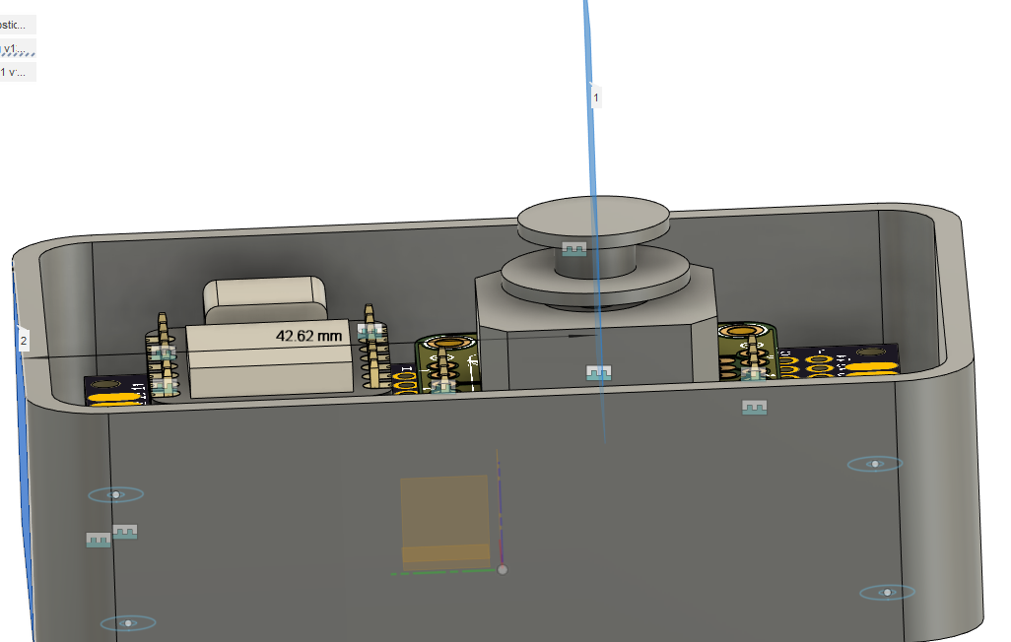

#### Interaction with Joystick

There is a design choice to make on how much of the top of the joystick is exposed out of the enclosure. Two options were considered.

Initially the approach was to center the upper housing between the two disks of the Adafruit joystick.

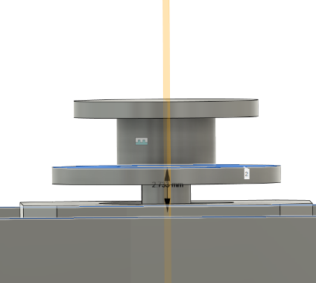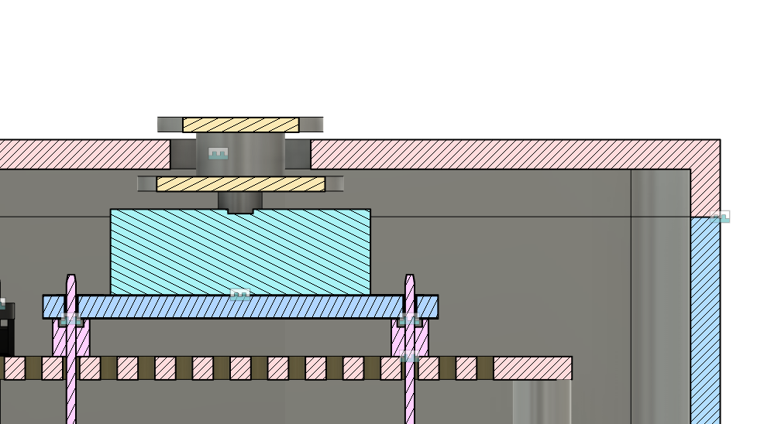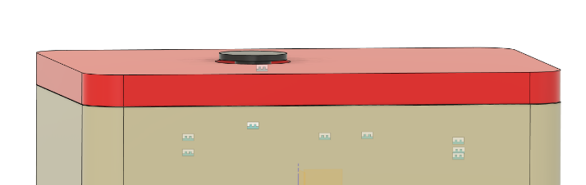

The thought behind this design was to have the lowest profile of the joystick coming out of the top of the enclosure if someone was resting their hand on it. Due to concerns about the clearance between the two disks and potentially users wanting to leverage the side of the joystick for movement, this approach was not selected.

Instead, the top of the housing was moved to as low as possible without having to increase the diameter of the hole in the top of the housing to expose the square housing of the joystick itself. The housing was lowered by removing 2 mm of height of the bottom enclosure to result in the following:

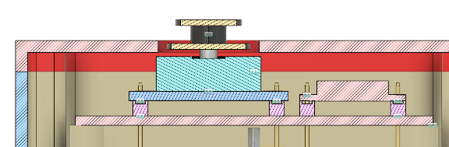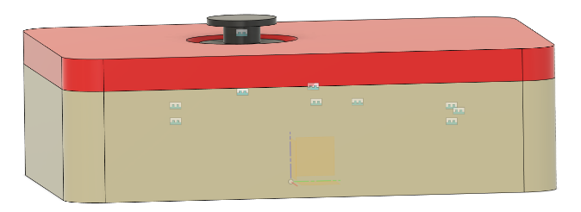

#### Top - Print Surface Edge

A 1 mm chamfer was added to the outer edge of the design along with a 0.5 mm fillet on each of those edges of the chamfer to add smoother edges while sill keeping the print quality high. Sharp print edges could be uncomfortable for users but adding a direct fillet on the part that will be the print surface can negatively impact print quality (refer to: <https://www.hydraresearch3d.com/design-rules>).

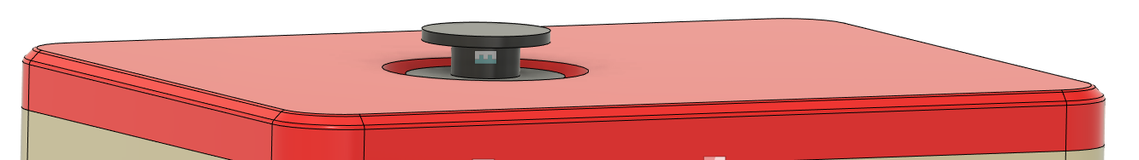

#### Directional indicator

An arrow was added on the top of the joystick and cut into the surface by 0.6 mm (three layer heights). This is to indicate the default front of the joystick. Future versions of this design could have the location of this arrow be customizable, such as with an overlay, so that the orientation of the joystick can be changed both in the code and on the enclosure and can be customized for the user’s preferred orientation.

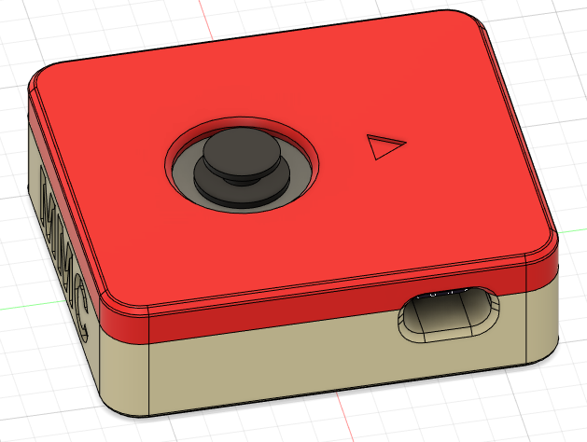

### Enclosure Assembly

To attach the two components of the enclosure, top and bottom, fasteners are used. This choice was made as M4 x 8 mm machine screws are already being used to mount the proto board so utilizing the extra parts that the order comes with makes sense from a cost perspective as well as ensuring a secure connection between the components. Snap fits were also considered but rejected. Snap fits can be really secure although with a gaming device being under potentially great forces (dropping or intense gaming) these are more likely to break.

2 mm holes are made in the four corners of the enclosure that are coincident with the radii of the outer fillets. These holes are then surrounded by material to add support for when the machine screw is inserted. These are 2 mm to allow the M2 screw to slide through with minimal resistance to get to the 1.8 mm hole on the top enclosure.

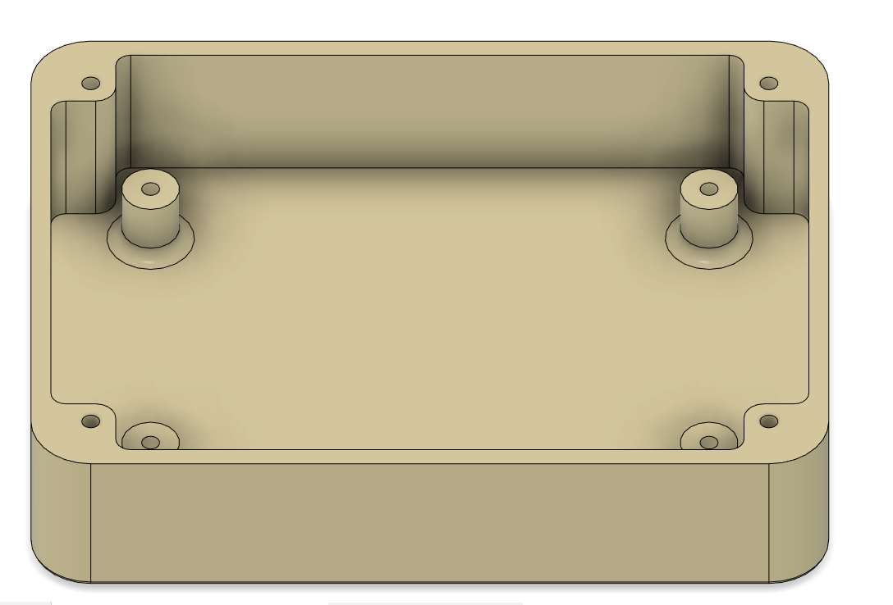

On the bottom of the enclosure a 4.2 mm hole with the same center point as the 2 mm hole. This is to allow for the head of the machine screw to fit inside. This is extruded so that 3 mm of the 6 mm self centering screw is showing out of the top of the housing that can be screwed into the top enclosure with a matching 1.8 mm hole (0.2 mm reduced so the machine screw can thread in).

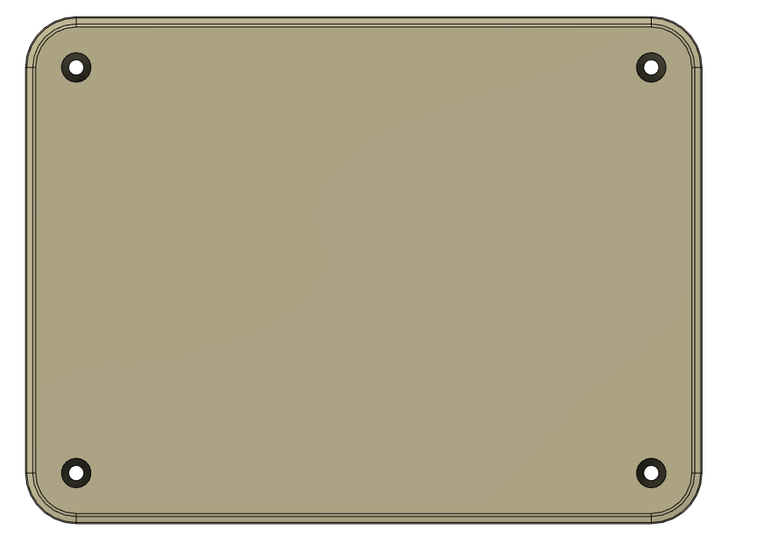

### USB Access Hole

A slot was cut out of the bottom and top component to allow for a 1.5 mm offset of the outer most edge of the USB C port to allow for thicker wire casings to enter the print.

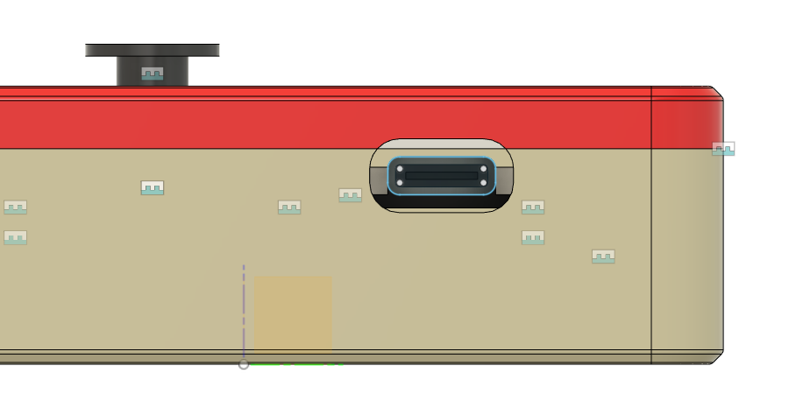

Although, with this design the outer face of the enclosure is quite far away from the USB C port on the board. This could make it difficult for users to make the connection between the USB C cable and the joystick device.

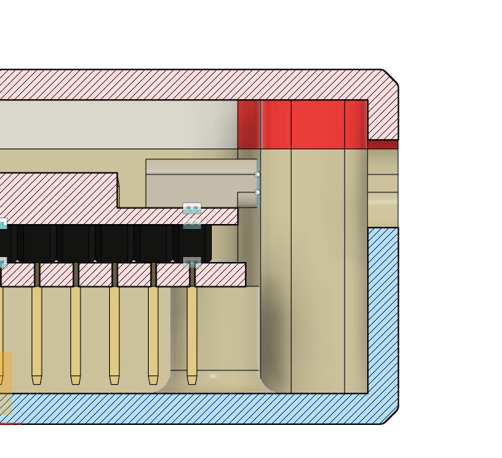

To solve this problem, guide walls were added on the inside of the bottom enclosure to help the user insert the cables. An opportunity for improvement in this design would be to incorporate strain relief.

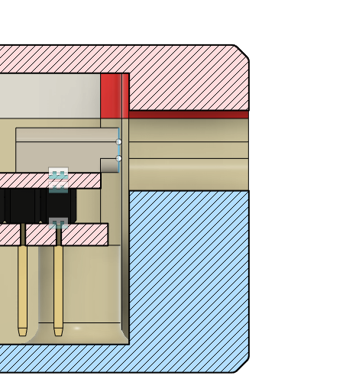

A chamfer was added on the outer face of the hole to help guide the user into the port to reduce chance of damaging the cable.

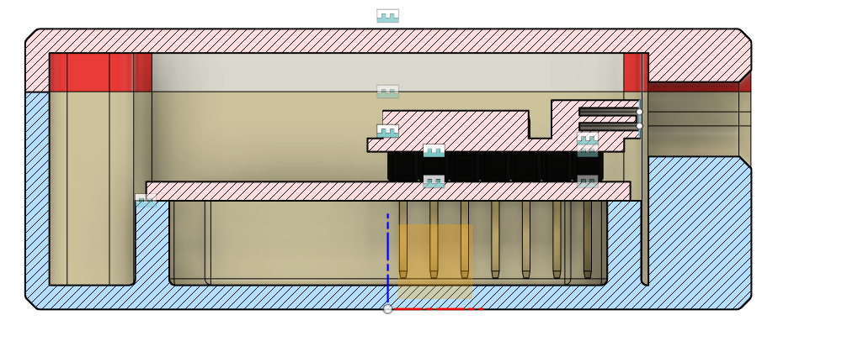

# Minimum Viable Product Design – V0.1

## Prototyping

### 3D Printing

Image of the two enclosures in the proper printing orientation from a top down view:

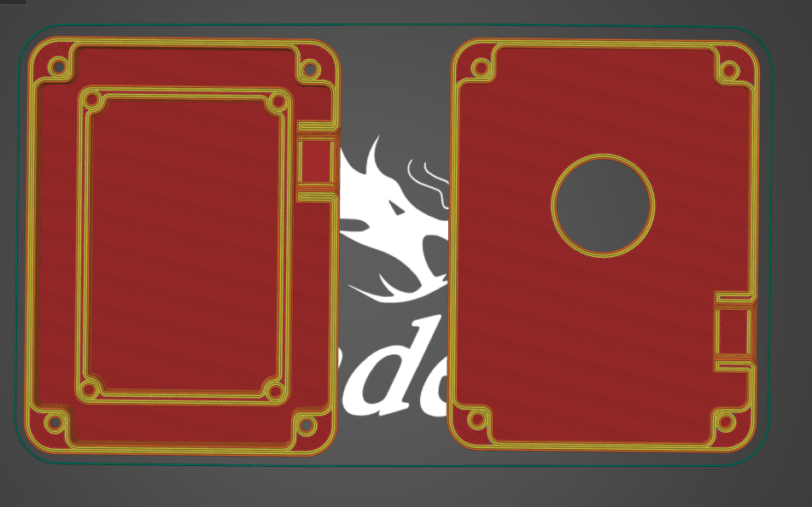

### Component Specifications

This is a space to take note of the components used in this design and their individual specifications.

#### Adafruit Mini 2-Axis Joystick

* Joystick: <https://www.adafruit.com/product/2765>
  + **Product Dimensions:** 17.5mm x 17.4mm x 12.0mm / 0.7" x 0.7" x 0.5"
  + **Product Weight**: 2.1g / 0.1oz
  + **Force required to move joystick:** Unknown
* Breakout board: <https://www.adafruit.com/product/3246>
  + **Product Dimensions:** 26.6mm x 25.4mm x 1.7mm / 1.0" x 1.0" x 0.1"
  + **Product Weight:** 2.3g / 0.1oz

This joystick has non standard leads and requires a breakout board for connection to prototyping boards like proto-boards. This joystick is only translational and has no indicated values for translational distance by manufacturer. By measuring with calipers, the approximate travel distance of the center of the joystick is 2.5 mm.

|  |  |
| --- | --- |
|  |  |

### BOM of Version 0.1

[Sliding_Joystick_BOM.xlsx](https://neilsquiresoc.sharepoint.com/:x:/s/MMC-RD/EWdbM_XkbQNHiEdMTO16rqABAmZTVXwHJ5iAW5NBfpH8TA?e=5SJme2)

|  |  |  |  |
| --- | --- | --- | --- |
| **Total Cost (per qty)** | **Total Maker Cost** | **Total Print time (hr)** | **Total filament (g)** |
| $ 27.99 | $ 44.91 | 4.37 | 38.99 |

## Internal Verification

### Housing and Assembly – OFIs to implement

* Add clearance into hole for joystick for when at maximum extension. (add approx. 1.2 mm to radius)
* Add a small disk to cover up the electronics on the inside (around 1.3 mm of room, so try 0.8 mm thick). Might need to add height to the cover to do this
* Make enclosure footprint smaller by eliminating some of the space around protoboard
* Add small rim on lid to align lid with case when assembling
* Wiring – think about order of assembly
* Add mounting option
* Add toppers

### Joystick function and code

* Joystick moves in the correct directions when plugged into the computer
* Joystick returns to center neutral position when released.
* At maximum extension of the joystick, the digital readings are at maximum values

# Design Changes Made for Version 0.2

## Mechanical

### Overview

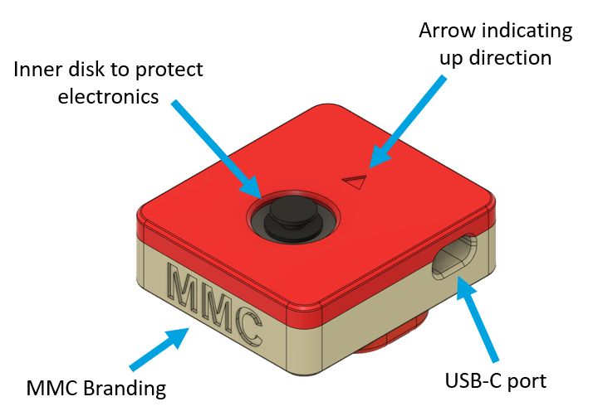

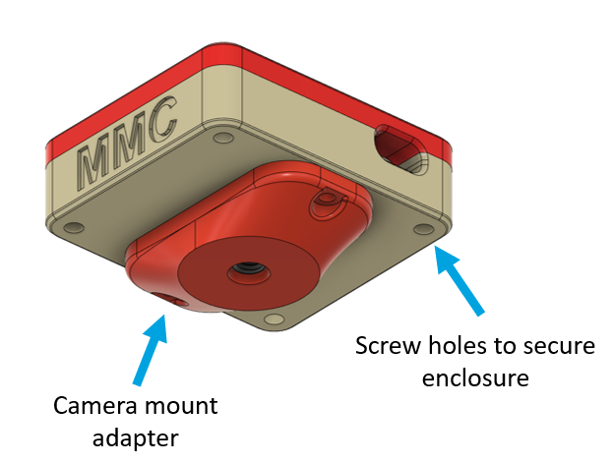

### Component 1 – Bottom of Enclosure

#### Size

The size of the joystick housing was reduced by reducing the space around the protoboard, and therefore reducing the size of the footprint of the joystick. This reduced the size of the joystick to 60 mm by 68 mm, with a height of 27 mm (including the top of the enclosure but without the topper). This also allowed the protoboard mounting posts to be incorporated with the outer edge of the enclosure, which will increase the strength.

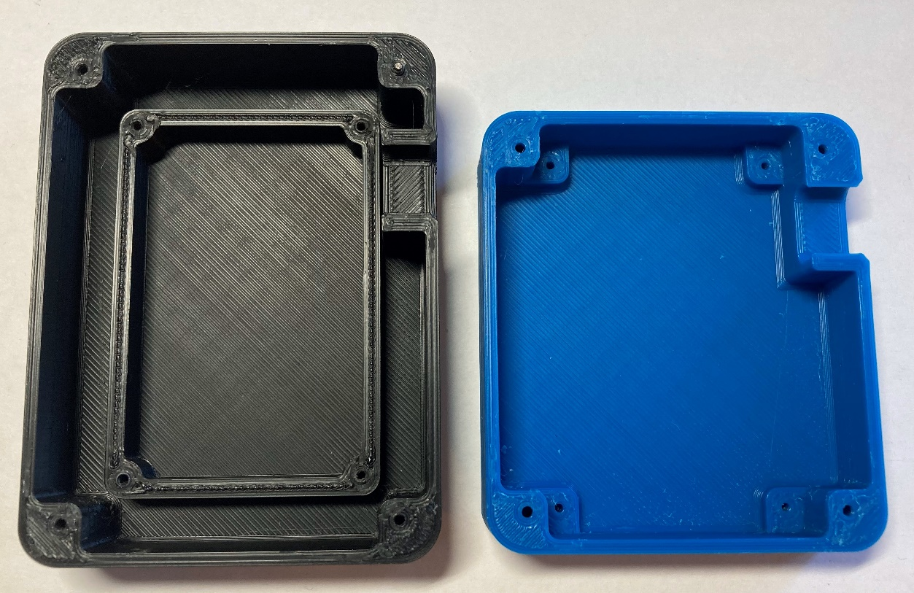

The protoboard used in this design is 40 mm x 60 mm, and the distance between the centres of the holes for the protoboard mounting is 36 mm and 56 mm, as shown below.

60mm

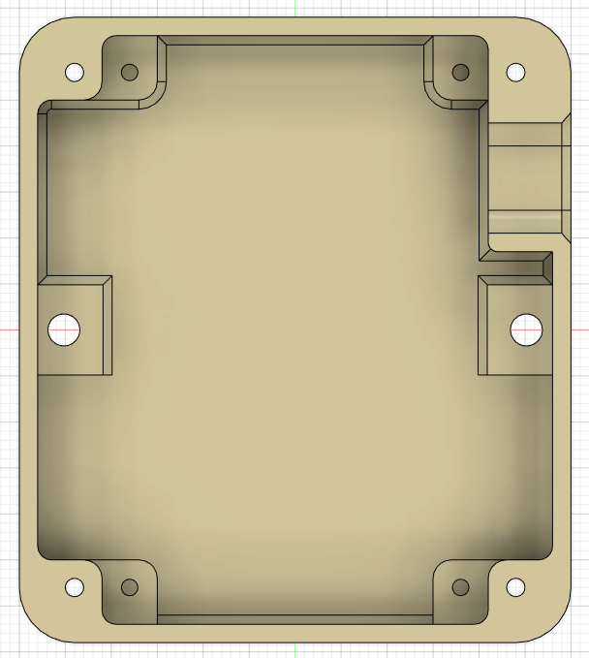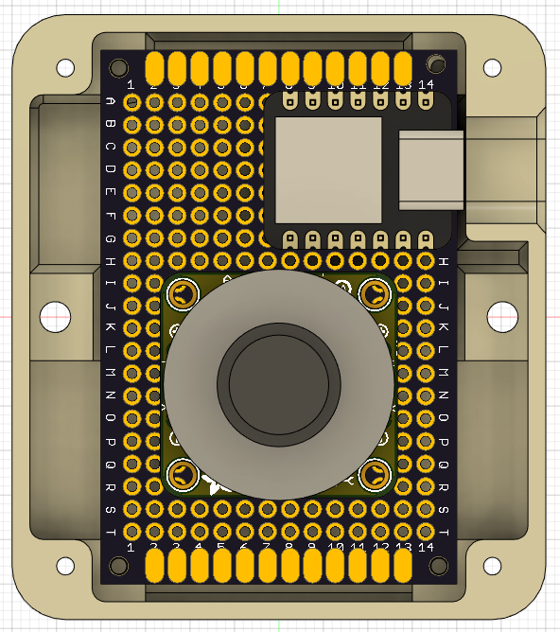

68mm

56mm

36mm

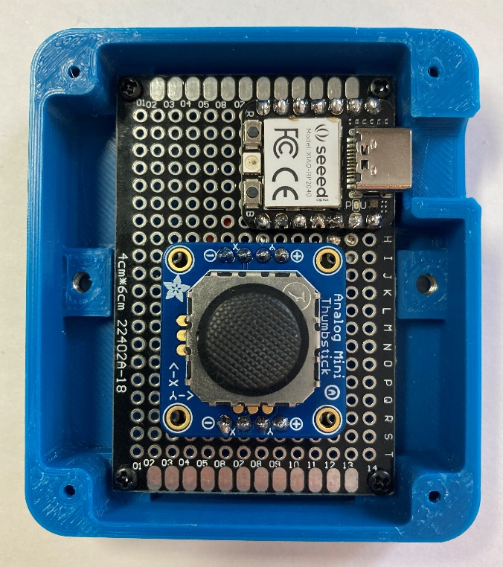

#### Mounting – Captive nuts

It was decided that this version of the design should incorporate a way to mount the joystick when not used on a tabletop. To do this, two slots for captive nuts were added, which would then screw into a separate mount adapter which will have the mounting hardware in it. Here, two M3 hex nuts are used. The centres of these nuts are 50.0 mm apart. These two slots are seen in the photos above, and then in a closer view below. As seen in the photo, around the hole above the captive nut, which would be printed unsupported, there are small single layer rectangles, [this is a best practice when 3D printing unsupported holes.](https://www.hydraresearch3d.com/design-rules#unsupported-holes)

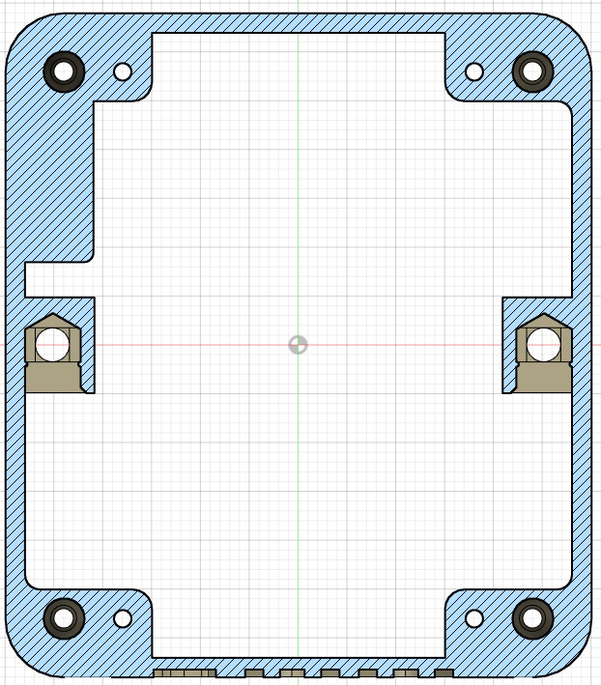 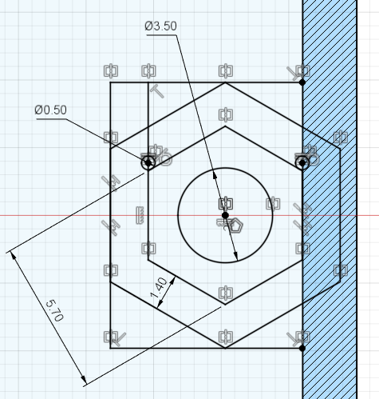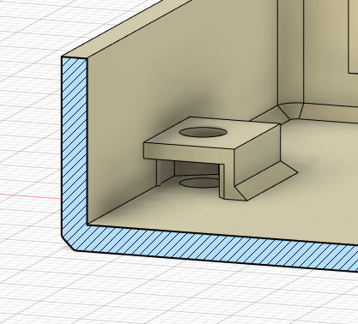

50mm

The hex nut is then slid into these slots and is kept in place by the small bumps on the sides.

### Component 2 – Top of Enclosure

#### Alignment tabs

To aid with alignment when assembling the joystick, tabs were added that are approximately 2.2 mm taller than the outer perimeter. These then sit inside the walls of the bottom of the enclosure, ensuring the two pieces are aligned properly. The clearance between these tabs and the wall of the bottom of the enclosure is 0.4 mm since this does not have to be a tight fit, and just allows the top and bottom to align more easily.

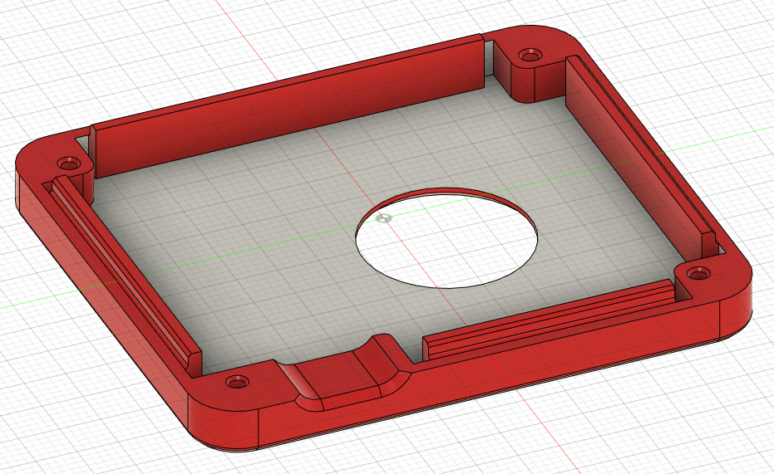 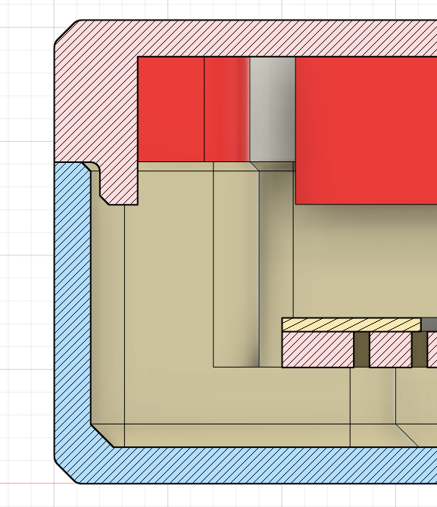

#### Hole for Joystick

The hole that the joystick goes through has a diameter of 20.4 mm to allow the joystick to move to its extents in each direction when used with the original topper.

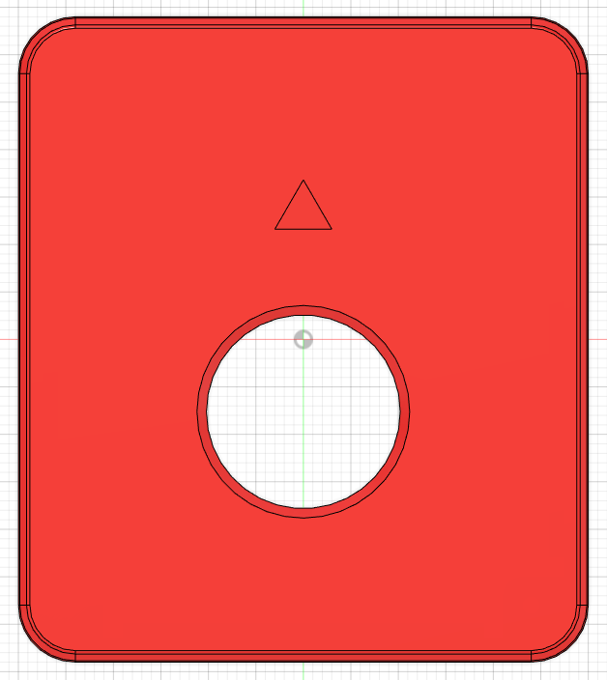

20.4mm

### Component 3 – Inner Cover Disk

To protect the inner electronics of the joystick, a small disk was added between the sliding joystick component and the topper. The photos below show how the disk is added to the joystick by removing the topper. The disk is 0.6 mm thick so it is thin but still has structural integrity by being three print layers thick. This disk does not need to be strong as there will be no bending force applied to it. It is important to look at the quality of this print, and if there are any bumps or zits, to either cut these off with a craft knife or use sandpaper to create a smooth surface and prevent binding.

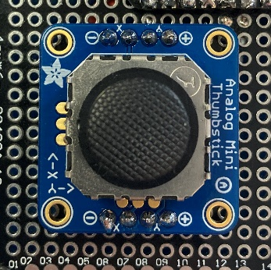 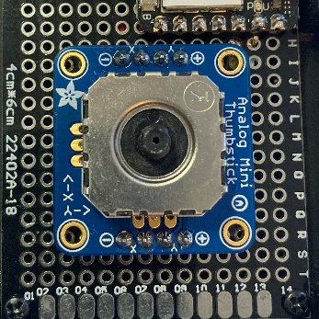 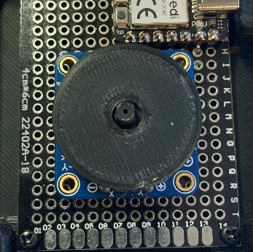 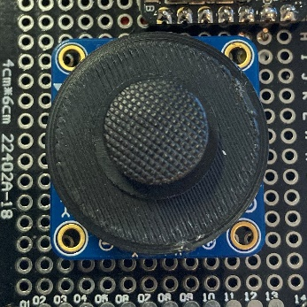

### Component 4 – Camera Mount Adapter

Using the M3 nuts installed in the bottom of the enclosure, a mount adapter can be attached to the bottom of the joystick using two M3 screws. For this initial version of the joystick, there will just be one mount adapter, which is designed to work with a camera mount with a ¼-20 thread. This is through the use of a ¼-20 barbed tee nut that is inserted into the camera mount adapter.

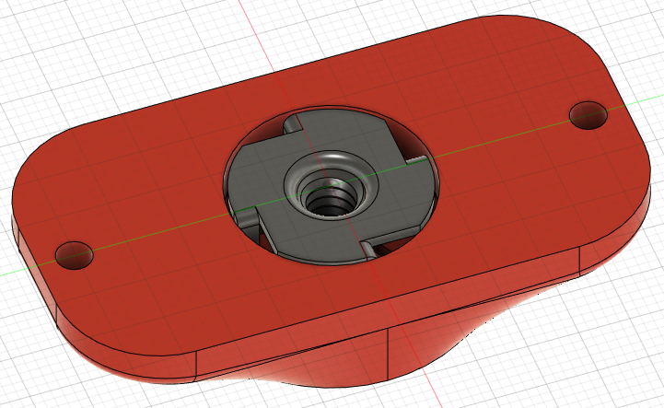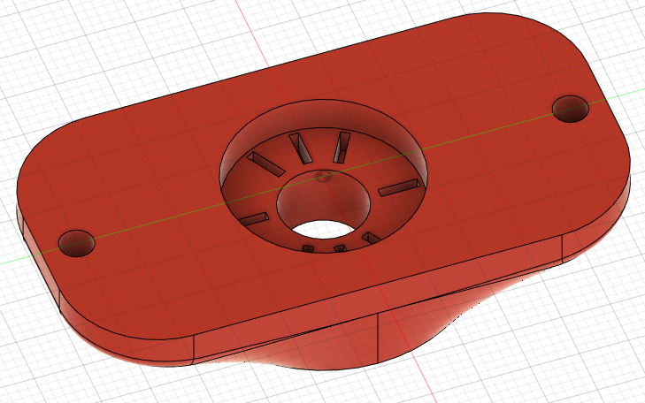

50 mm

When installed on the bottom of the joystick, the camera mount can be screwed into the bottom of the mount adapter. The distance between the holes to connect the mount adapter to the joystick is 50 mm from centre to centre.

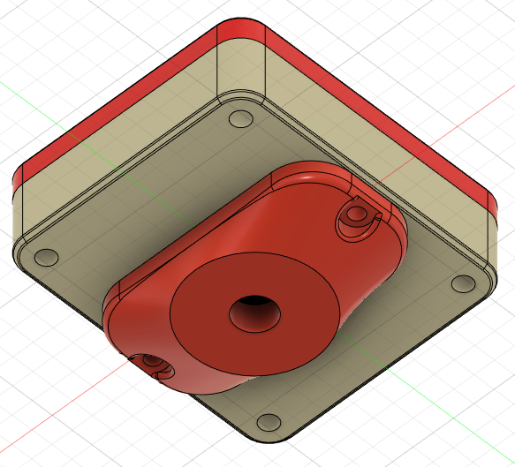

### Component 5 – Toppers

A set of 5 toppers were created, with a press on fit using the existing peg on the joystick.

It was found through a fit test with a few different shapes and sizes, that a rectangular hole measuring 3.1 mm x 4.1 mm with curved corners of radius 1 mm would fit the best on this peg, since it is not circular. The depth of this hole on the toppers is 2.5 mm to ensure a secure fit and prevent binding.

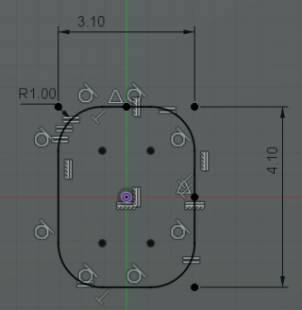

All of the toppers are pictured below, from left to right: small dome topper, medium dome topper, ring topper, concave topper

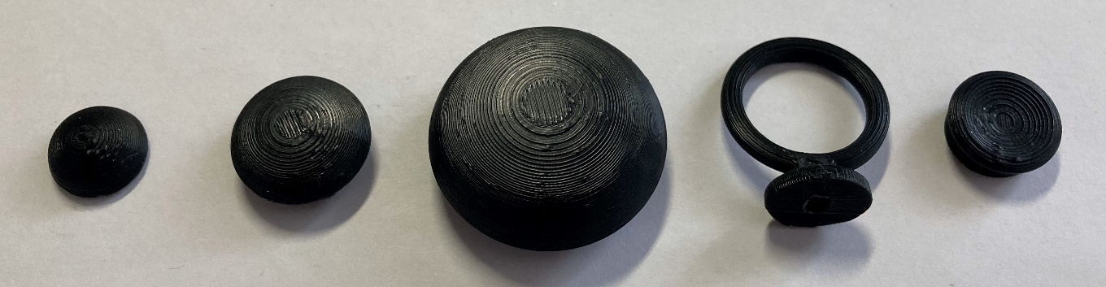

#### Topper 1 – Small Dome

The first topper created is a small dome topper. This topper has a diameter of 14 mm, equal to the diameter of the bottom diameter of the original topper, so it was made as a simple dome with a slightly flattened top for improved 3D printing.

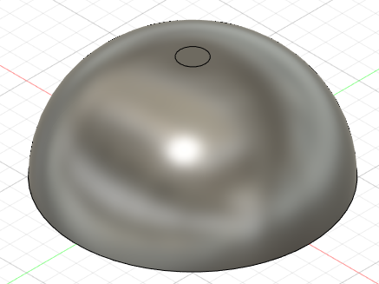 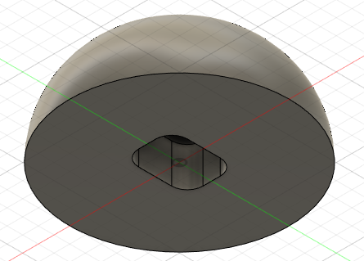

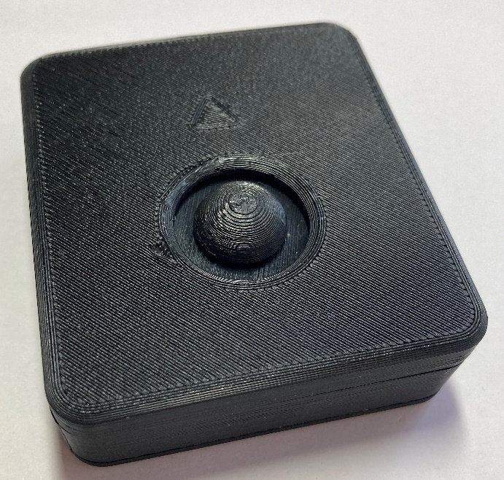

#### Topper 2 – Medium Dome

The second topper created is a slightly bigger sized dome. The diameter of the largest part of this topper is 20 mm, and since this is too big to fit inside the circle on the top of the enclosure when the joystick is at full extension, it had to be raised up on a cylinder with a smaller diameter. The diameter of the bottom surface is 14 mm, equal to the original topper, to fit inside the circle on the top of the enclosure. This lip between the smaller cylinder and the dome does mean the topper has to be printed with supports but this choice was made to keep the topper low profile, and allow it to be printed in one piece.

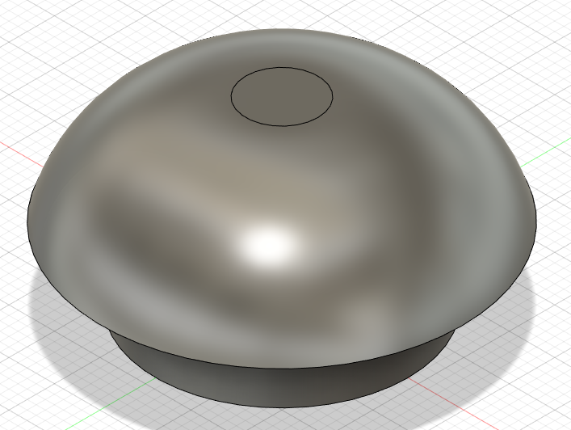 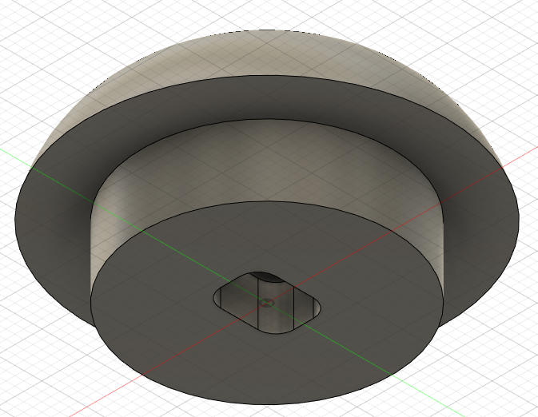

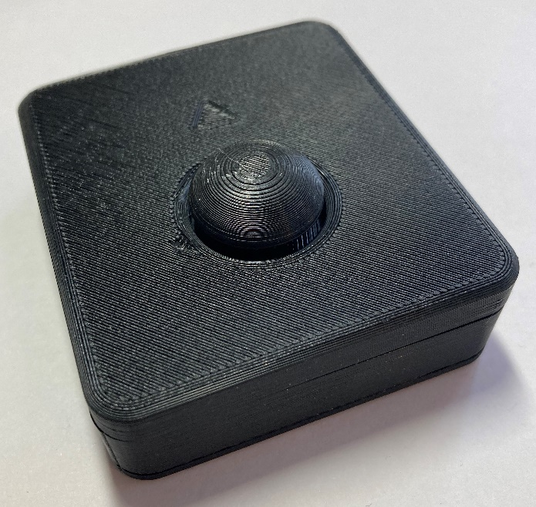

#### Topper 3 – Large Dome

The third topper created is another dome that is slightly bigger than both other dome toppers. The diameter of the largest part of this topper is 34 mm, and again this was too big to fit inside the circle on the top of the enclosure so it was raised up on a cylinder with a smaller diameter. The diameter of the bottom surface is 14 mm, equal to the original topper, to fit inside the circle on the top of the enclosure. This topper also has to be printed with supports, but this choice was again justified by the desire to keep the topper low profile and allow it to be printed in one piece.

A future solution to investigate could be to make this topper and the medium dome topper two pieces so that supports aren’t needed but this would also add more prints and more pieces that need to fit together tightly.

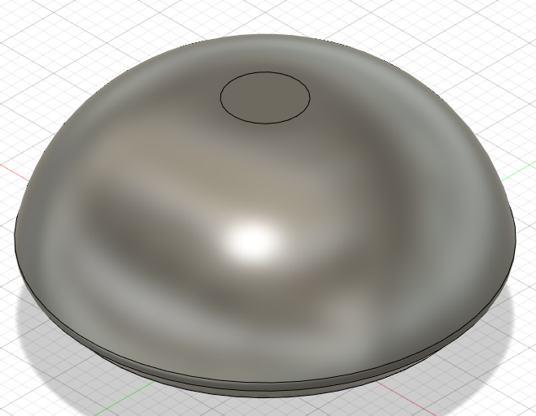 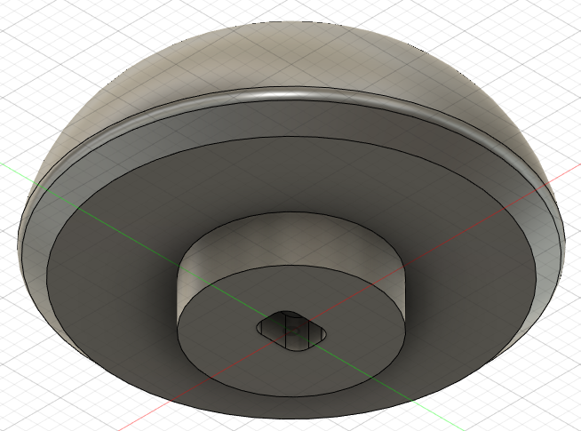

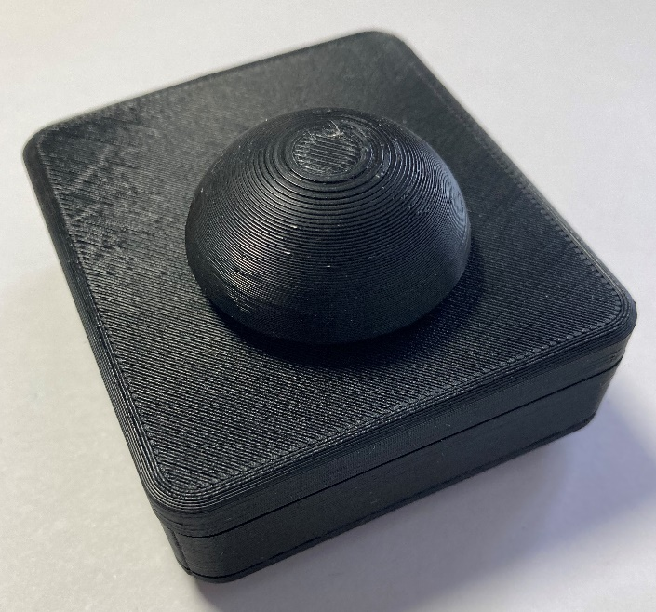

#### Topper 4 – Ring

The fourth topper has a ring shape that the user slides their finger into. This design was inspired by a suggestion from an occupational therapist. This topper should be printed with the ring parallel to the build plate for the most strength, and must use supports. The bottom surface of the topper is an octagon since this does not affect function but will make it easier to print than a circle printed perpendicular to the build plate.

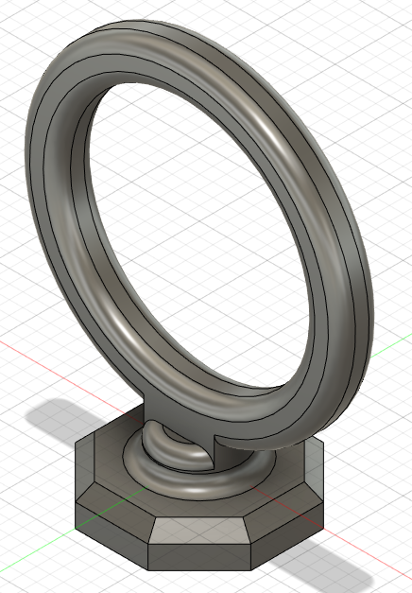 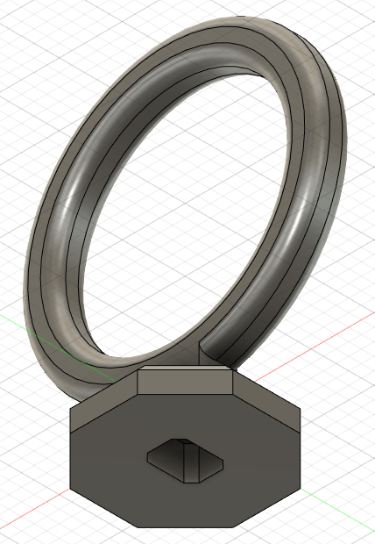

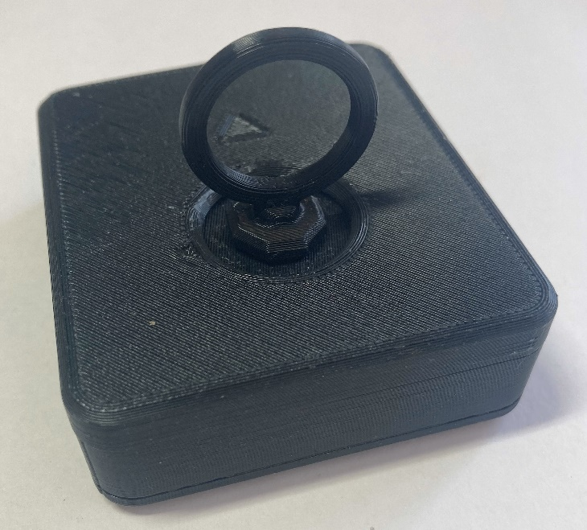

#### Topper 5 – Concave

The fifth topper has a concave shape on top, similar to the thumbsticks on some standard gamepads, such as on an Xbox controller. The diameter of the bottom surface is 14 mm, and the max diameter at the top is 16 mm, which is a similar size to the thumbstick on an Xbox Elite controller. This topper prints without any supports.

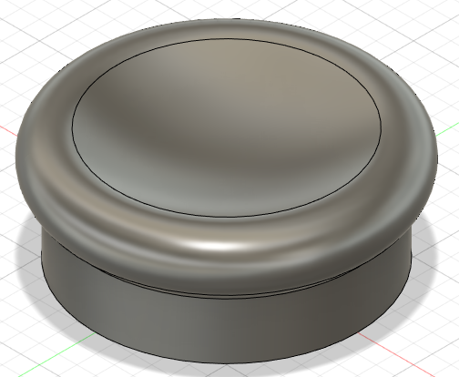 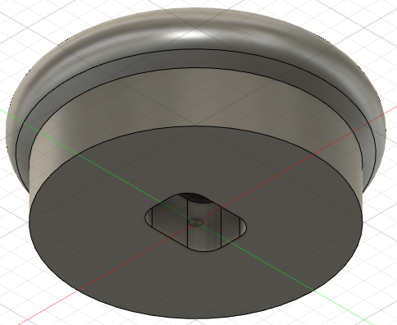

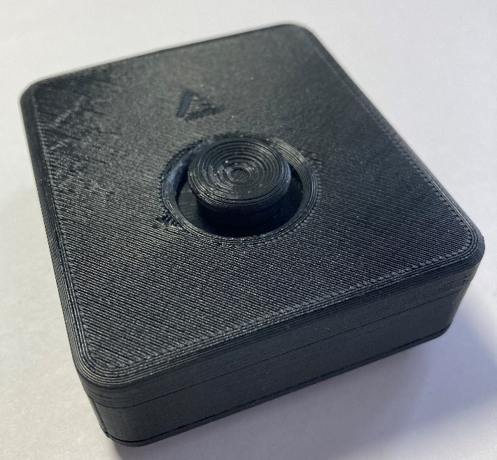

## Electrical

### USB Version

The USB version of this design uses the joystick, the joystick breakout board, and the XIAO RP2040 Microcontroller, which are all mounted on a prototyping board and connected with 24 awg wire.

The connections are as follows:

|  |  |
| --- | --- |
| **Seeed XIAO baord** | **Joystick breakout board** |
| 3v3 | + |
| GND | - |
| D0 | Y |
| D1 | X |

These connections are also seen in the sketch below.

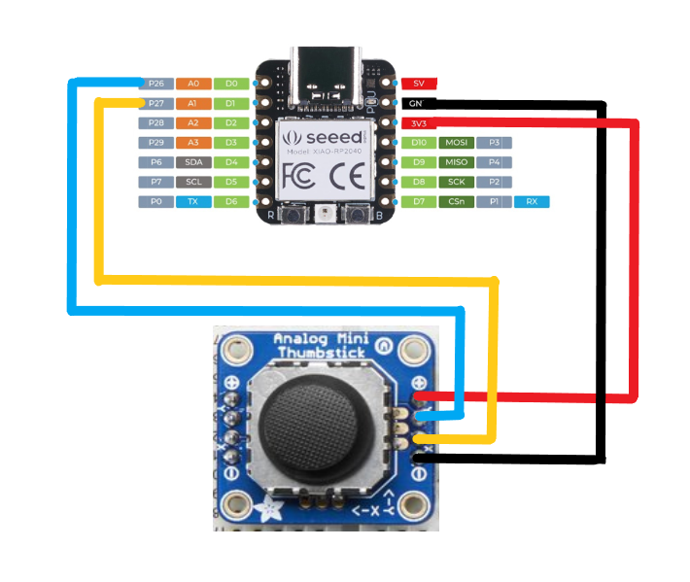

The Seeed XIAO RP2040 board and the joystick board are mounted on the top and soldered in place using male headers, and the wiring is done on the bottom, as shown in the photos below.

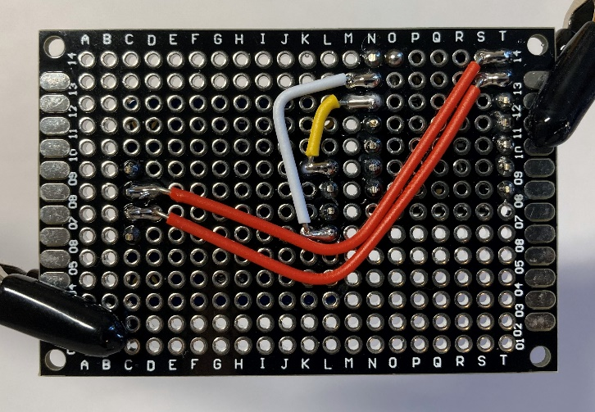 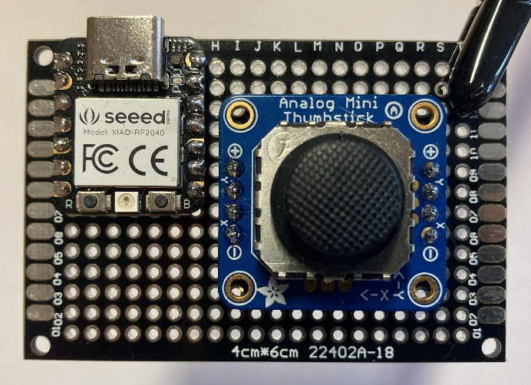

#### 3D printed overlay

To help with ease of assembly for the USB version, a 3D printed overlay was created that has holes where the microcontroller and the joystick breakout board are placed, as well as holes for the wiring.

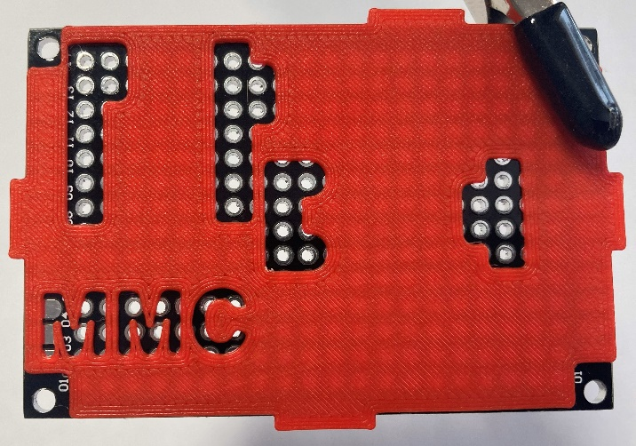 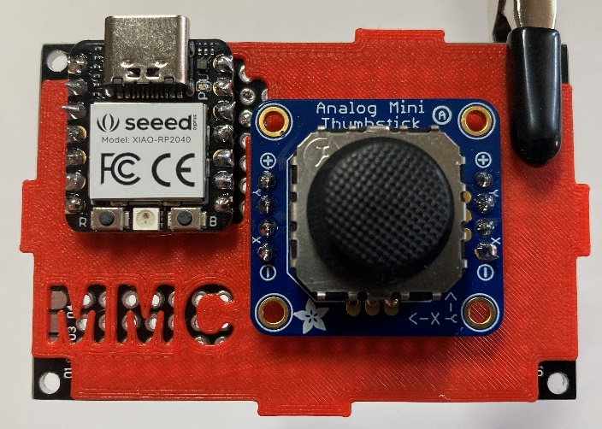

This will prevent the microcontroller and joystick breakout board from being placed in the wrong locations, which is easy to do without the overlay. It also helps prevent wires from being placed in the wrong locations, but the instructions must still be followed carefully in order to do the wiring correctly.

### Analog Version – Birch Mini Joystick – A (3.5 mm TRRS Cable)

The other version of this joystick uses a 3.5 mm stereo cable with TRRS connections, which can be plugged into game controllers like the Xbox Adaptive Controller. The wiring below was done to match the connections on the Xbox Adaptive Controller.

The connections for this version are as follows:

|  |  |
| --- | --- |
| **TRRS Cable** | **Joystick breakout board** |
| Tip (T) | Y |
| Ring 1 (R1) | X |
| Ring 2 (R2) | - |
| Sleeve (S) | + |

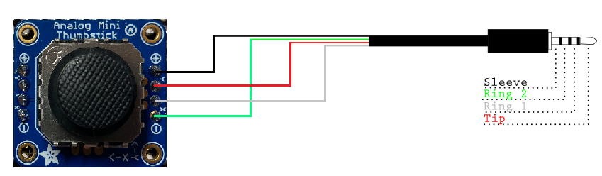

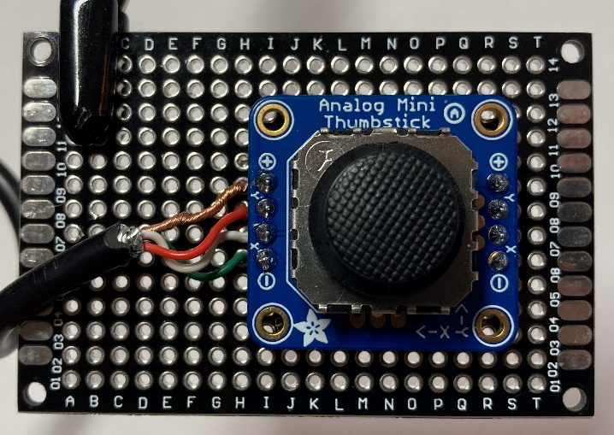

## Final Design Overview (V0.2)

* Cost
  + USB Version
    - Unit cost: $35.64 ($27.64 for parts, $8 shipping)
    - Total maker cost: $50.93 ($42.93 for parts, $8 shipping)
  + 3.5 mm Analog Version:
    - Unit cost: $20.17 ($12.17 for parts, $8 shipping)
    - Total maker cost: $38.86 ($30.86 for parts, $8 shipping)
* Print time (with no optional prints):
  + USB version: 3 hours 11 mins
  + Analog version: 2 hours 57 mins
* Total 3D printer filament used:
  + USB version: 27.7 g
  + Analog version: 26.0 g
* Approximate build time: 1 hour
* Size:
  + Height: 2.1 cm without topper, 2.4 cm with original topper
  + Width: 6.0 cm
  + Length: 6.8 cm

# External Validation

### User Testing

To get user feedback, two Birch Mini Joysticks each were sent to three rehabilitation centres and were looked at by occupational therapists as well as tried with clients. The feedback was generally positive, and any opportunities for improvement are summarized below:

* Sensitivity – one rehab centre felt the joystick response was too sensitive for large movements and was too jerky to use for camera control in game
* Sliding motion – one centre liked it, another said they prefer a joystick with a pivoting motion
* Orientation – one centre said they prefer the current orientation of the joystick, one said they felt it would be valuable for the orientation to be customizable for different users, so that some users could rest their hand on the longer side
* Size – one centre said the size of the joystick was appropriate, and that it would have a negative effect if the joystick were any taller
* Two centres said they would prefer if the USB-C cable were integrated into the joystick and not removable, but only if this could be achieved without adding size to the joystick
* Toppers
  + The concave topper was the preferred topper for two of the rehabilitation centres
  + One centre said they thought all toppers would be useful for different applications
  + The ring topper was found to not stay on good enough

## Opportunities for Improvement

Opportunities for improvement that could be investigated in the future for another version:

* Sensitivity – some users found the joystick too sensitive, one possible solution for this is to offer different response profiles that could be selected and modified by the user
* Integrate the cable into the housing (if this is possible without making the joystick bigger)
* Uses M2 self tapping screws which are not common or easy to find, and often have to be bought in bulk

# Version 1.0

For version 1.0, the analog and USB variants have been separated, and the analog variant now has a new enclosure and a new name, the Aspen Sliding Joystick. The Aspen is much smaller than the Birch and has snap fits instead of using screws. The Aspen Sliding Joystick has its own repository and its own design rationale explain the changes made and the new enclosure.

The Birch USB variant, formally named the Birch Mini Joystick-U, is now named the Birch Sliding USB Joystick. No design changes are being made to the Birch Joystick, just the name change and some documentation updates. This design rationale will represent the Birch Sliding USB Joystick design progression.